**VISVESVARAYA TECHNOLOGICAL UNIVERSITY**

**“JnanaSangama”, Belgaum -590014, Karnataka.**



**LAB REPORT**

**on**

**Object Oriented Modelling and Design**

***Submitted by***

**MITHIL RAJ (1BM19CS086)**

***in partial fulfillment for the award of the degree of***

**BACHELOR OF ENGINEERING**

***in***

**COMPUTER SCIENCE AND ENGINEERING**



**B.M.S. COLLEGE OF ENGINEERING**

**(Autonomous Institution under VTU)**

**BENGALURU-560019**

**April-2022 to July-2022**

**B. M. S. College of Engineering,**

**Bull Temple Road, Bangalore 560019**

(Affiliated To Visvesvaraya Technological University, Belgaum)

**Department of Computer Science and Engineering**



**CERTIFICATE**

This is to certify that the Lab work entitled “**Object Oriented Modelling and Design**” carried out by **MITHIL RAJ (1BM19CS086),** who is a bonafide student of **B. M. S. College of Engineering.** It is in partial fulfillment for the award of **Bachelor of Engineering in Computer Science and Engineering** of the Visvesvaraya Technological University, Belgaum during the academic year 2021-2022. The Lab report has been approved as it satisfies the academic requirements in respect of a **Object Oriented Modelling and Design- (20CS6PCOMD)** work prescribed for the said degree.

**MADHAVI RP**               **Dr. Jyothi S Nayak**

Designation Professor and Head Department of CSE Department of CSE

BMSCE, Bengaluru BMSCE, Bengaluru

`

**Index Sheet**

|  |  |  |
| --- | --- | --- |
| **Sl. No.** | **Experiment Title** | **Page No.** |
| **1.** | **COLLEGE INFORMATION SYSTEM** |  |
| **2.** | **HOSTEL MANAGEMENT SYSTEM** |  |
| **3.** | **STOCK MANAGEMENT SYSTEM** |  |
| **4.** | **COFFEE VENDING MACHINE** |  |
| **5.** | **ONLINE SHOPPING SYSTEM** |  |
| **6.** | **RAILWAY RESERVATION SYSTEM** |  |
| **7.** | **GRAPHICS EDITOR SYSTEM** |  |
|  |  |  |
|  |  |  |
|  |  |  |
|  |  |  |
|  |  |  |
|  |  |  |
|  |  |  |
|  |  |  |

**Course Outcome**

|  |  |
| --- | --- |
| **CO4** | **Ability to conduct practical experiment to solve a given problem using Unified Modeling language.** |

**1. COLLEGE INFORMATION SYSTEM :-**

a)**SRS:-**

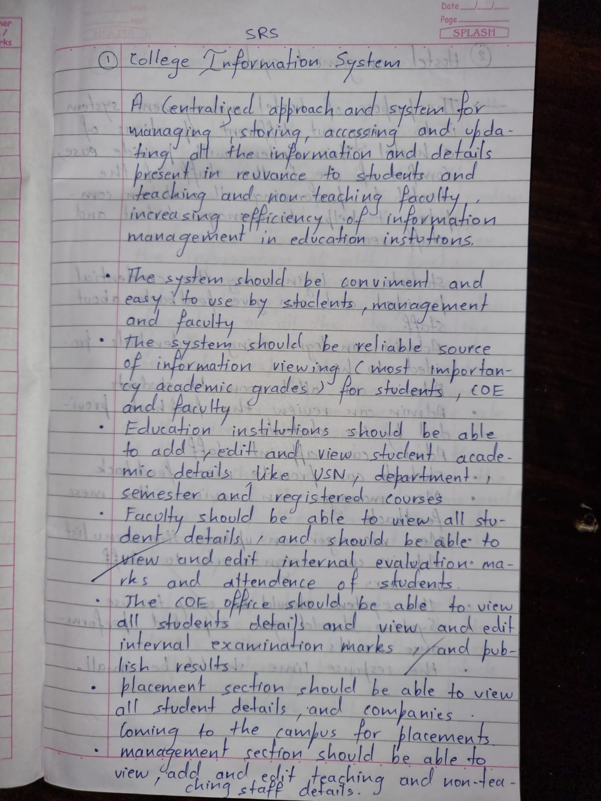

b) **advanced class diagram:-**

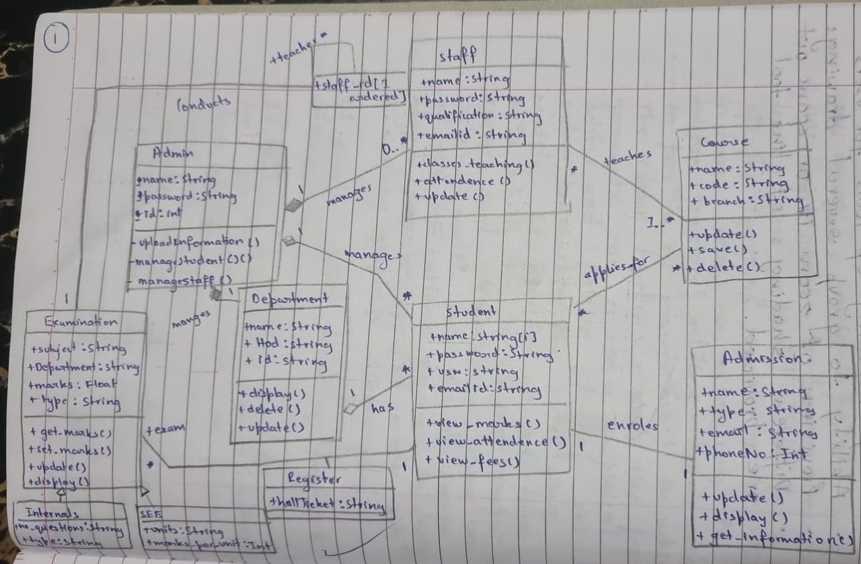

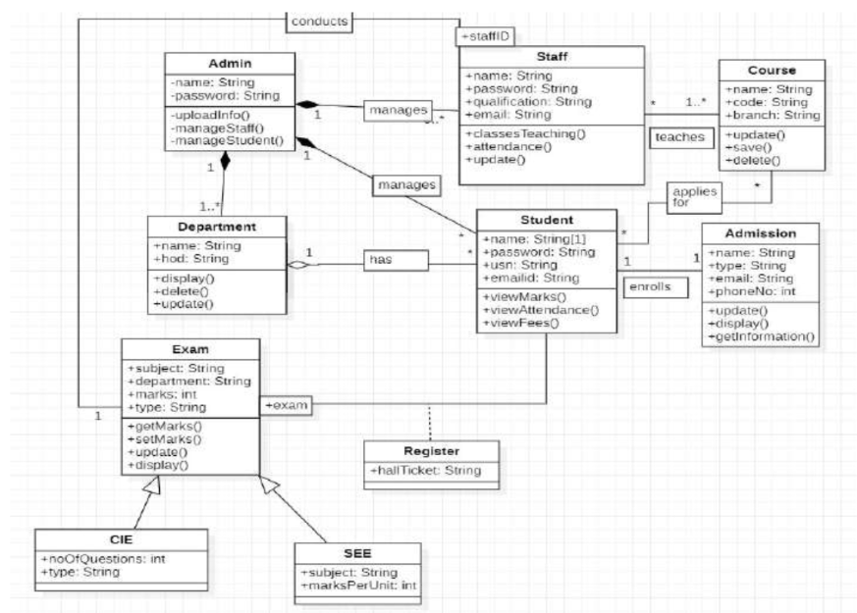

Admin can view and modify the srudent’s records,teachers and department details.the student of the college register themselves in the department and examination and for the course they are interrested in and join the college by taking admission and following all the admission procedures.college condusts internals and semester end examination for student.

C) advanced state diagram:-

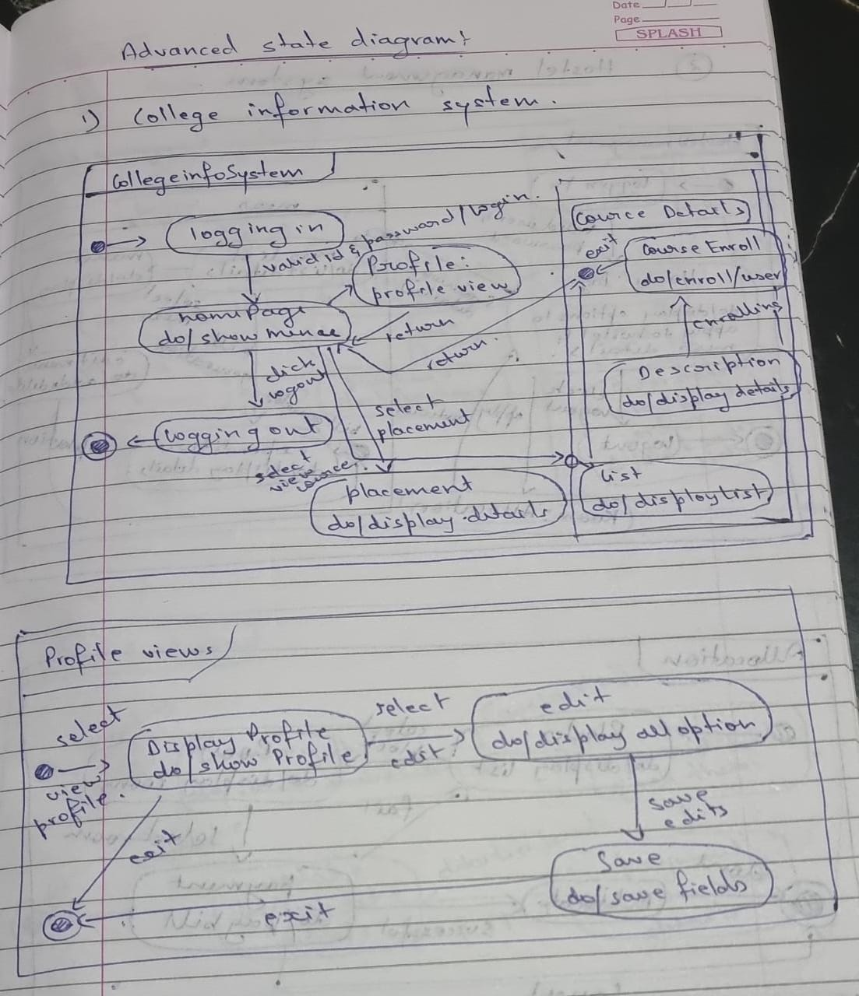

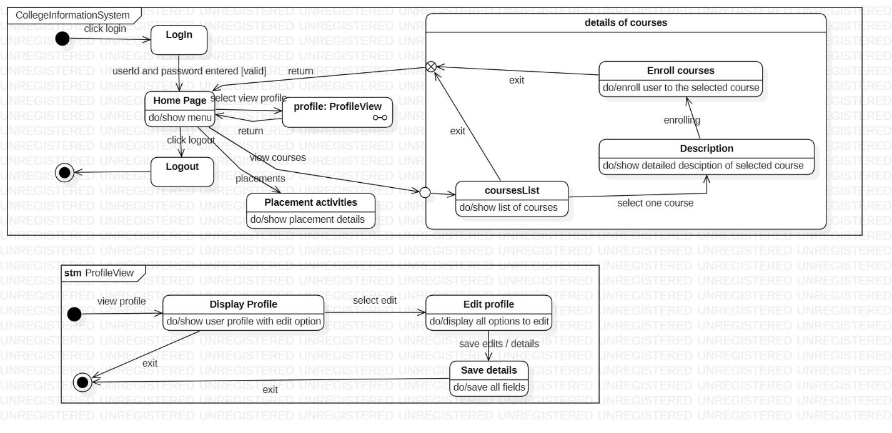

The above state diagram describes the states the admin goes though in uploading information of student,

staff and department. The admin first needs to login which then leads to the validate state where the login

id and password are validated. If invalid it then goes back to the login state or goes to the get information

state. Upon receiving the correct information it goes to the upload state and then to commit state to save

all changes. The admin first needs to login and be cleared of their permissions. The admin can then

manage information related to the student, teacher, or department.After necessary changes the admin can

update the information and logout from the system.

C) **Advanced use case diagram:-**

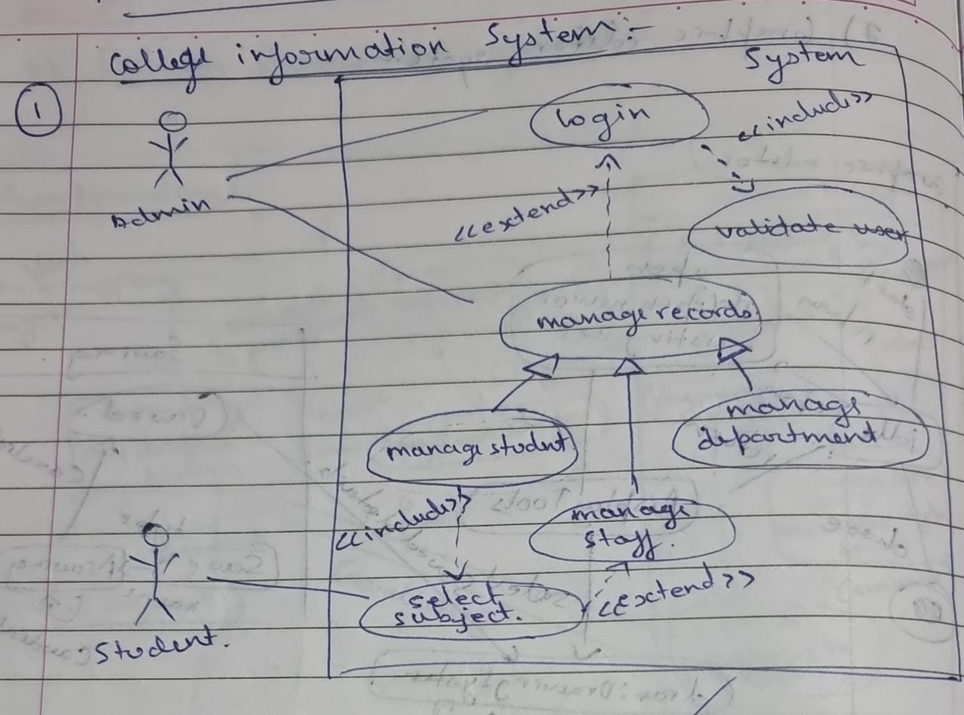



**Actors:**

Admin:the person who manages everything

Student: A person who uses the system

**Use Cases:**

Manage details: the admin can update, insert or delete the data.

View results: displays the result of students.

Subject details:various details related to subject is displayed.

View student details: the details of student is displayed

D) advanced sequence diagram:-

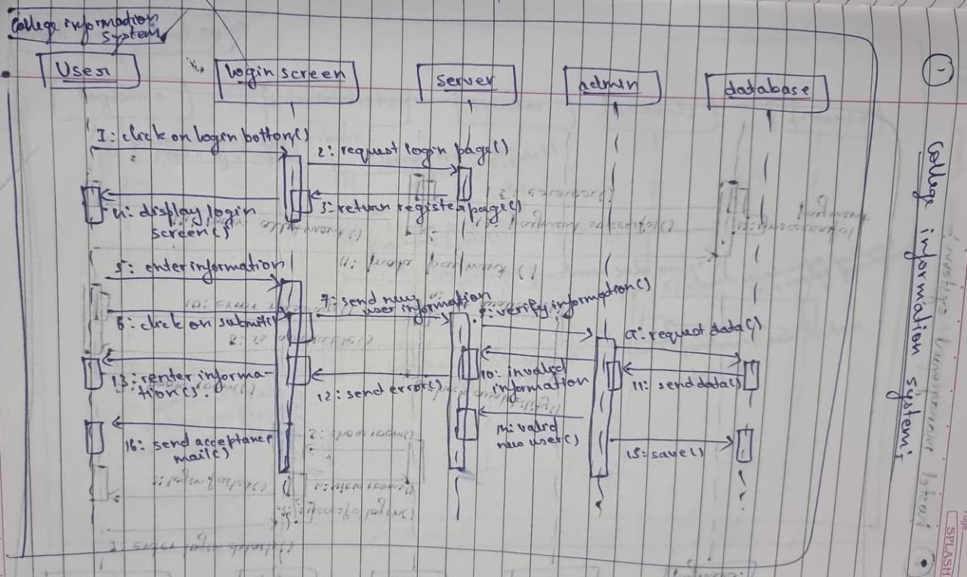



The above sequence diagram gives the interaction between objects while a user is logging into a system.

The user enters login information in the website which sends to the server, where the information is

validated and the appropriate reply message is displayed to the user.

E) **Advanced activity diagram:-**

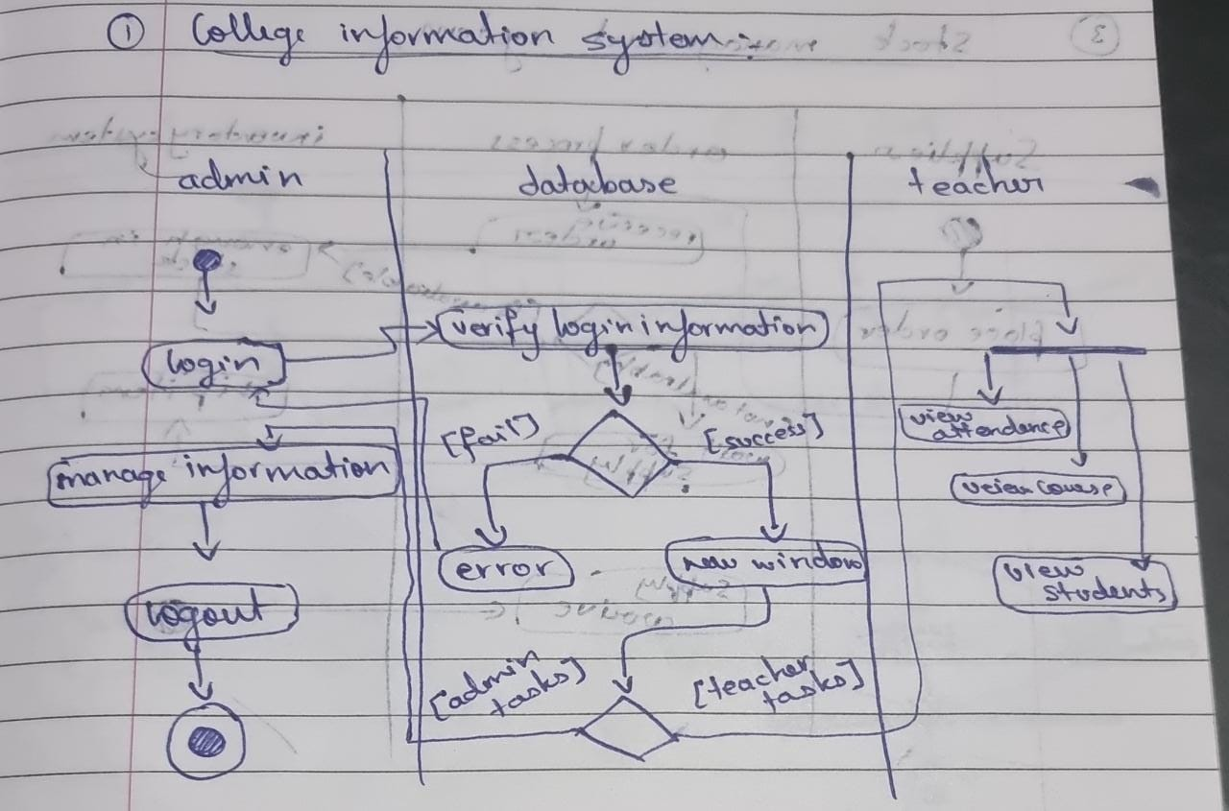

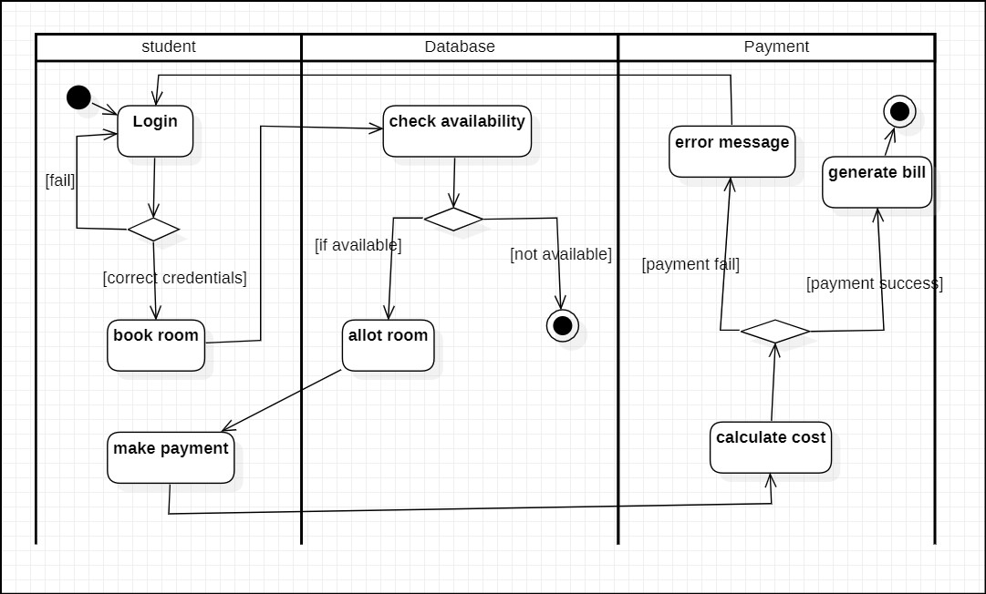

The above activity diagram has three swimlanes mainly admin, database and teacher. The admin can login

and manage information. The database verifies the login information and on success has two options. He

teacher can view attendance, view course details, and view student list.

2. **HOSTEL MANAGEMENT SYSTEM :-**

A) SRS

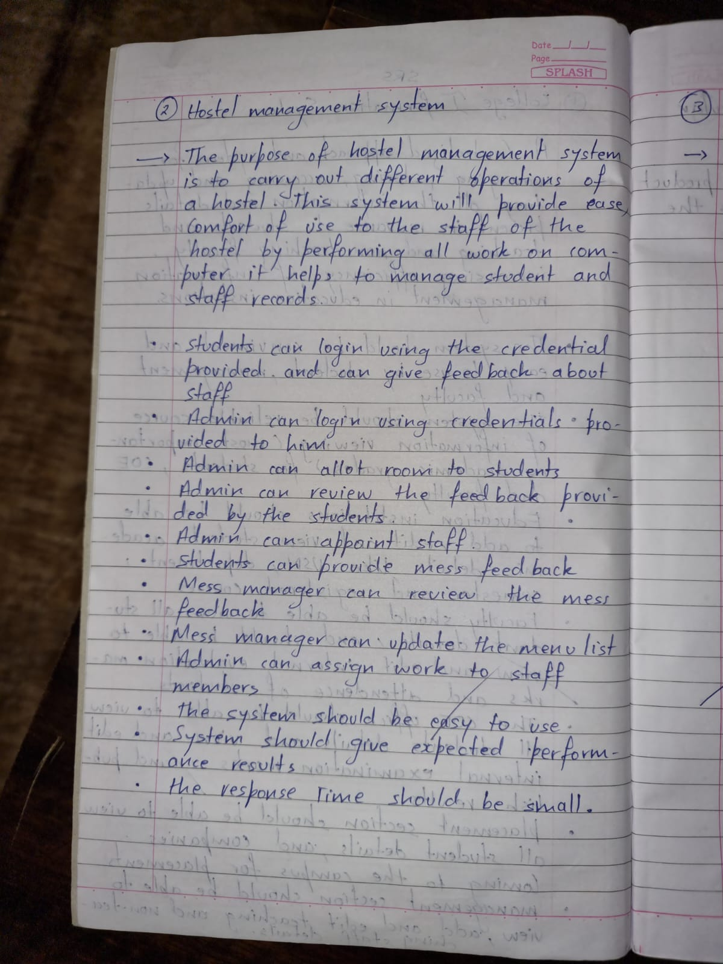

B) **Advanced class diagram :-**

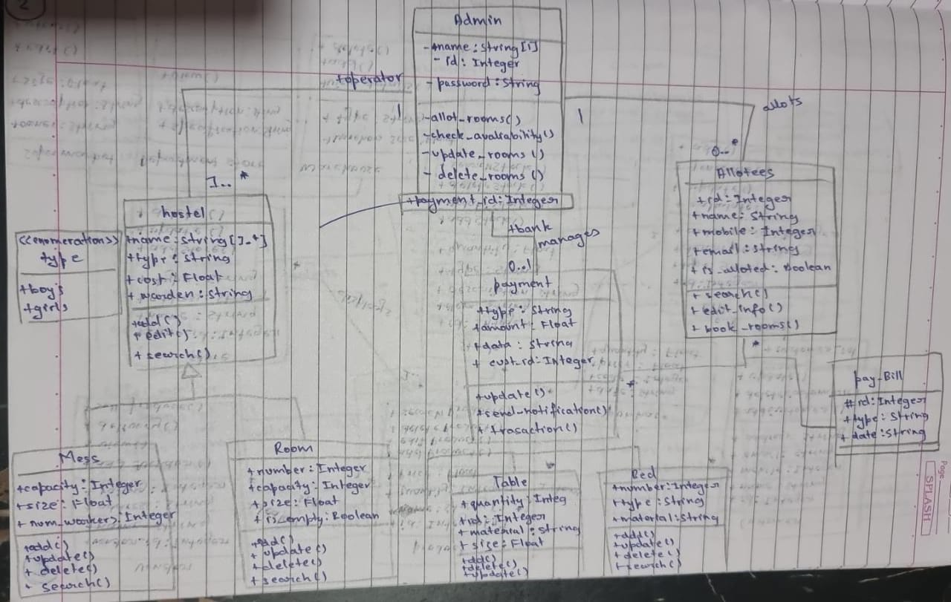



Hostel management system has admin who manages the hostel, allot-es and payment methods.The allotes

makes payment according to the bill generated which have the attributes bill number, type and date.The

hostel is categorized into two types I.e boys and girls hostel.A hostel is made up of mess and rooms.A

mess account will also generate. This account having the mess status of the whole month.

C) **Adanved state diagram :-**

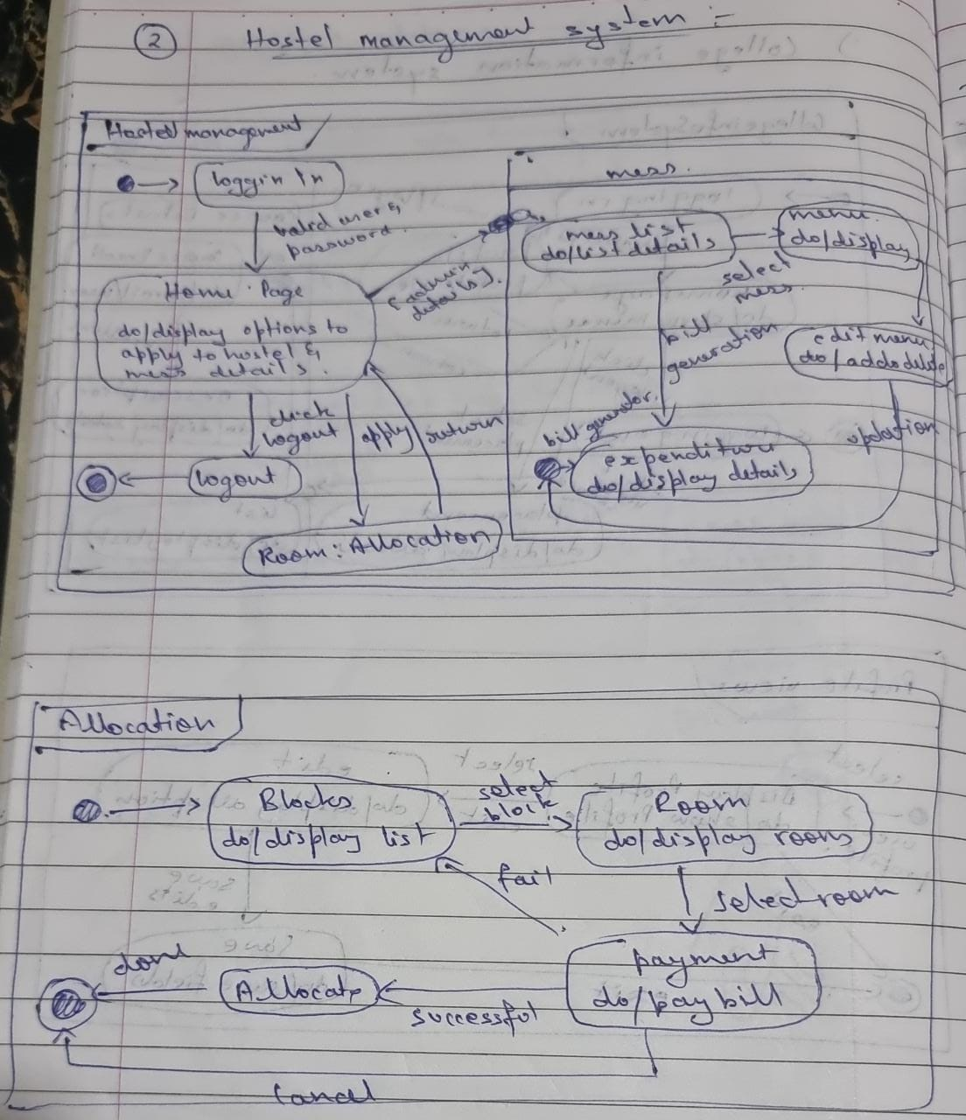

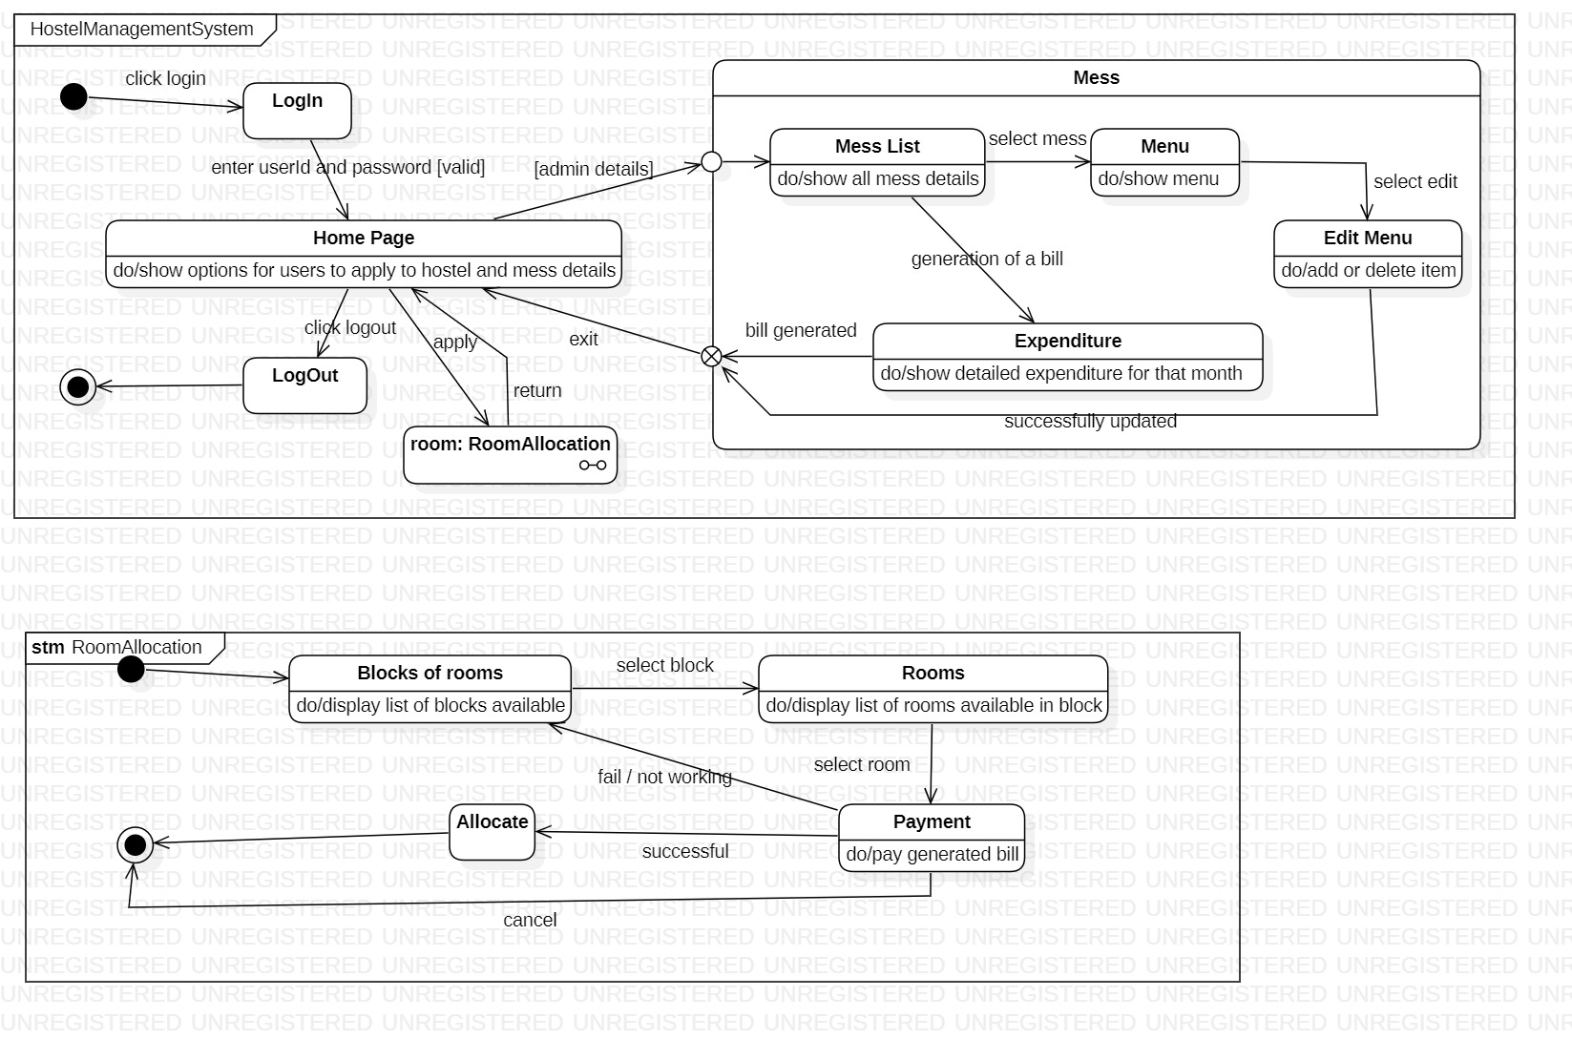

The above state diagram gives the movement of states in allotting a room to a student. The admin allots

rooms for students. The admin first login s to the database ,which displays a set of options.the admin then

chooses to allot rooms and finds the availability for rooms. If rooms are available then the admin allots

room to the student and when successful the student makes the payment. If no rooms are available, a

message is displayed and control goes back to the display state.

D) **Advnaced use case diagram : -**

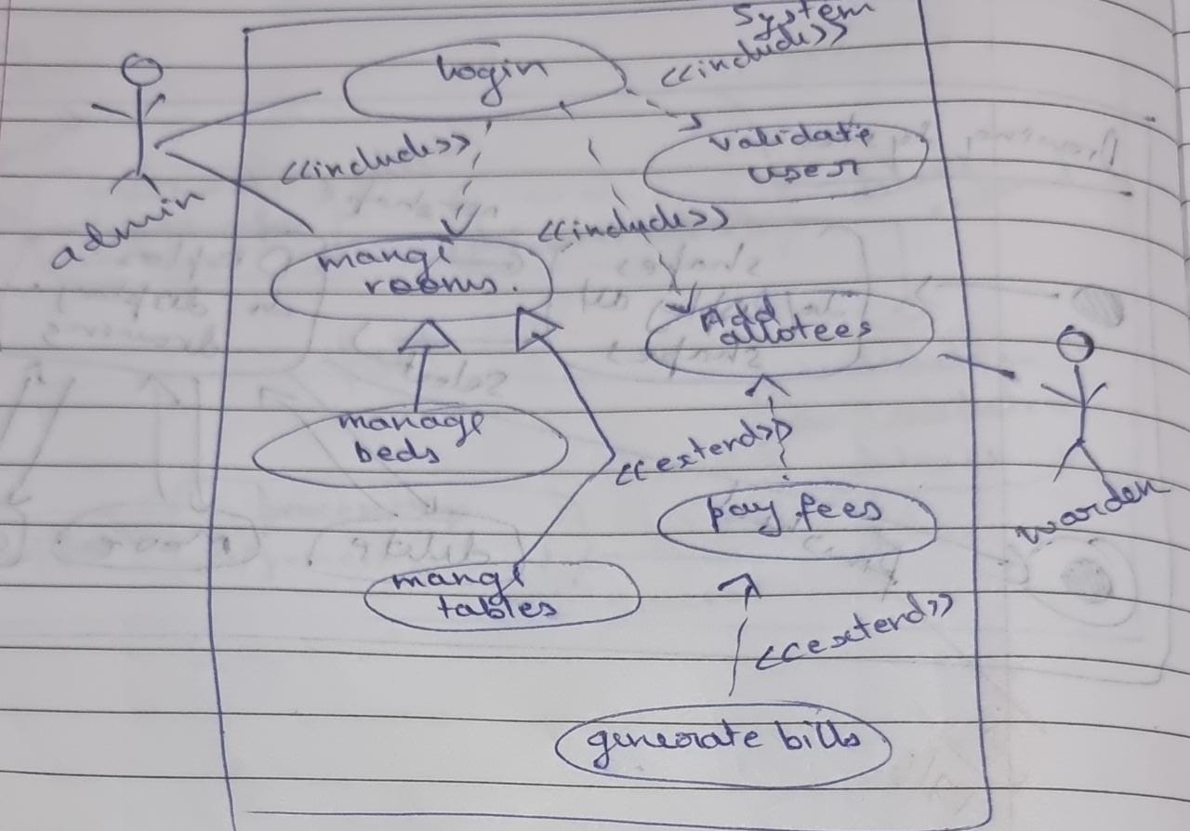



**Actors:**

Admin: the person who manages the whole system

Warden : the person who manages the allottees

**Use Cases:**

Manage hostel : allows actor to update delete or add information

Login : allows actors to login into the system.

Add allottee: the students are allotted hostel rooms

Book hostel: the student can select the hostel they wish to stay in.

E) **Advanced sequence diagram :-**

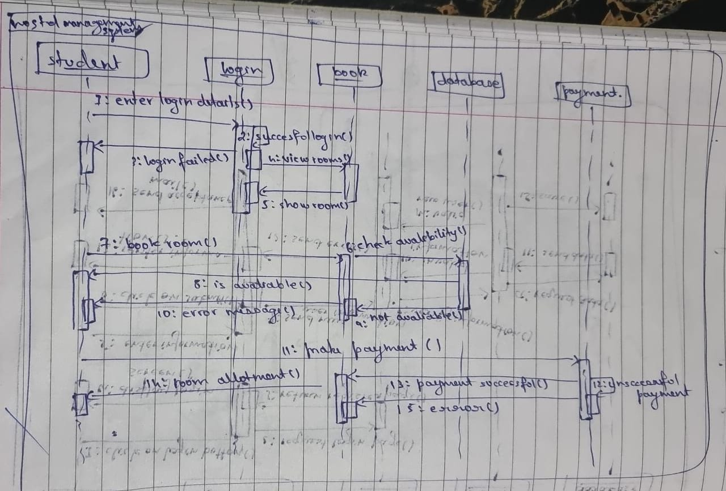



The above sequence diagram give the steps involved in a student logging in, booking a room, which is

verified in the database and the payment for the same is made by the student.

F) **Advanced activity diagram:-**

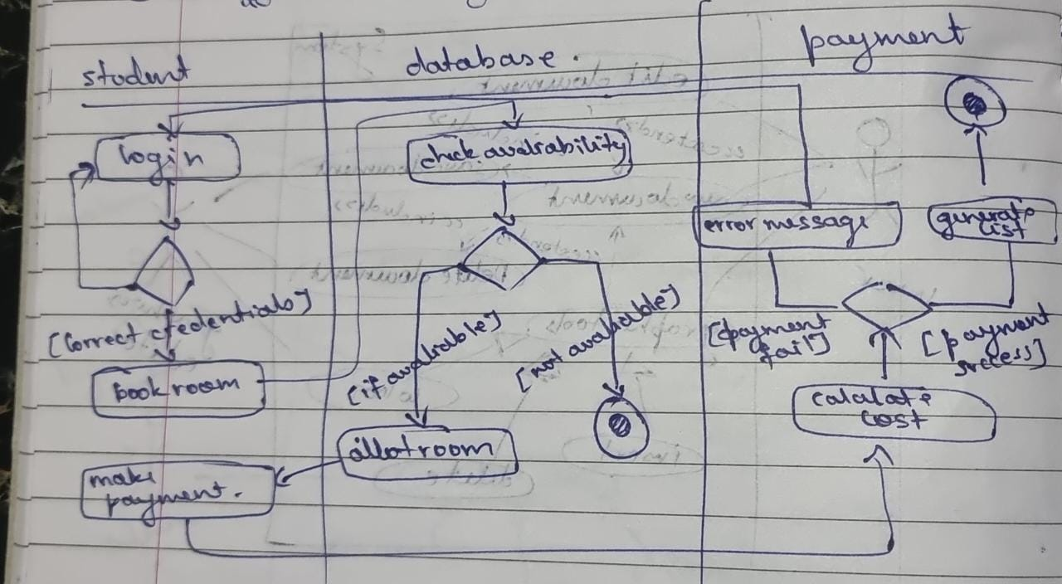



The above activity diagram give the steps involved in a student logging in, booking a room, which is

verified in the database and the payment for the same is made by the student.

**3. STOCK MANAGEMENT SYSTEM :-**

A) SRS

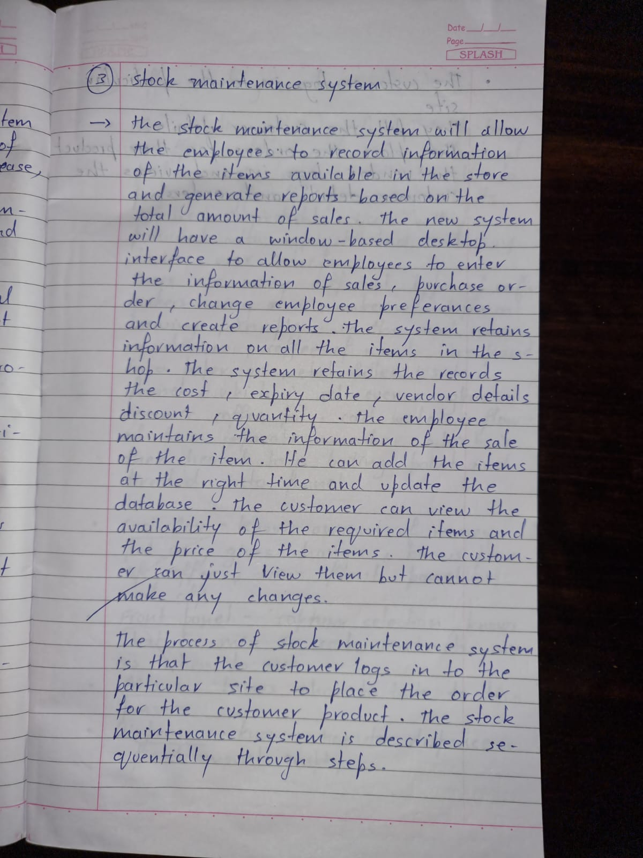

B) **Advanced class diagram:-**

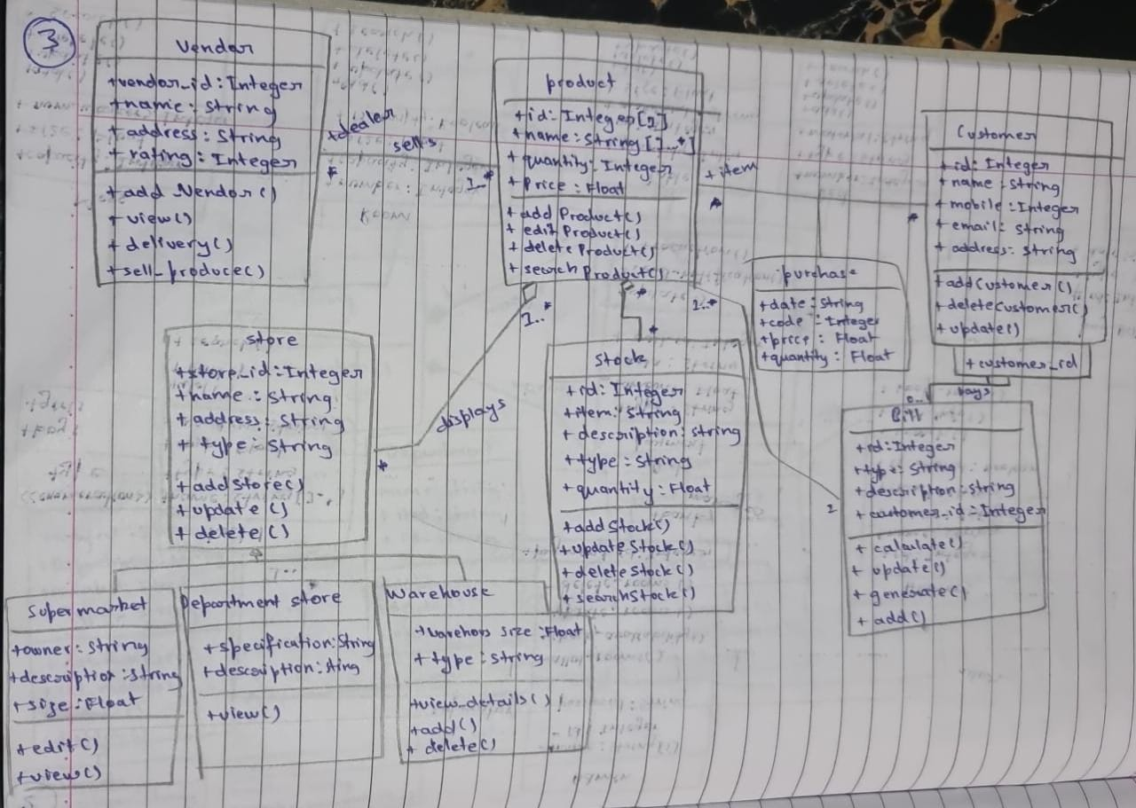



The products are displayed in stores across the city or world. All the information regarding the store are used to

locate any product.The stores can be of many types.Some of them are departmental stores, super markets and ware

houses where the products are kept for display.The vendor deals with the information about the details of the

suppliers giving product to the organization.The stock of the products is maintained separately.The stock deals with

information about the details of the product that the concern handling.

C) **Advnaced state diagram :-**

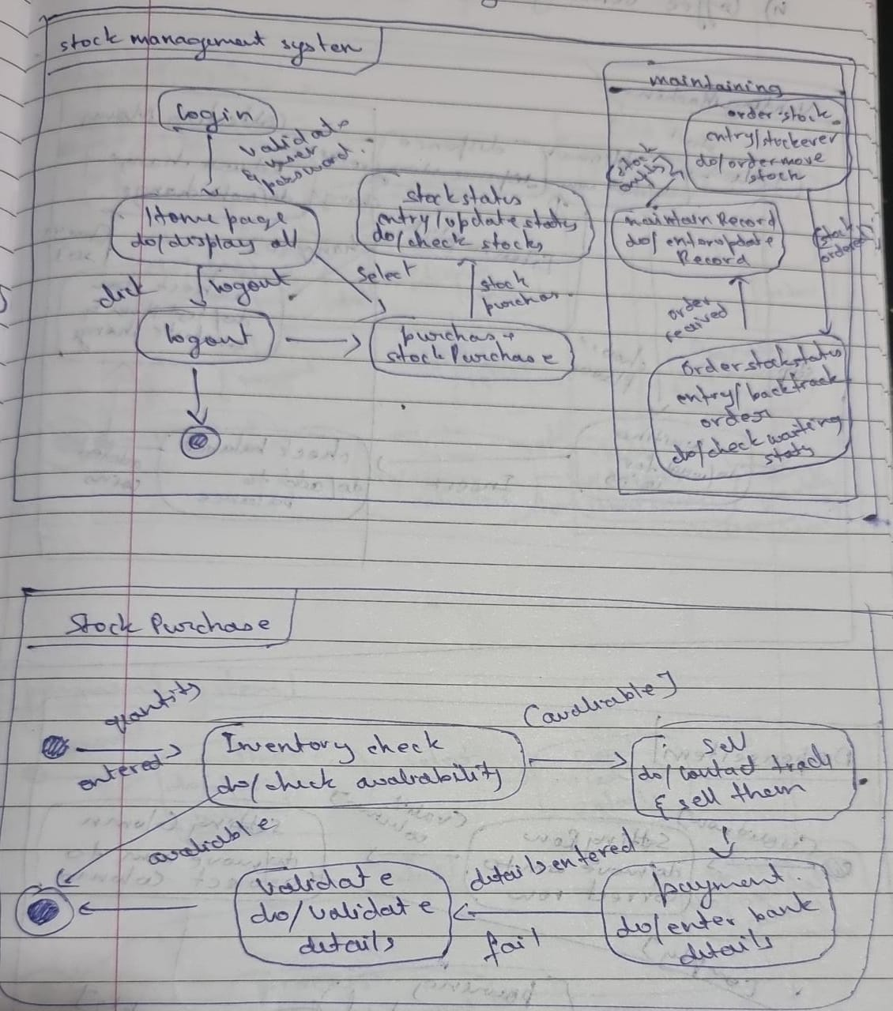

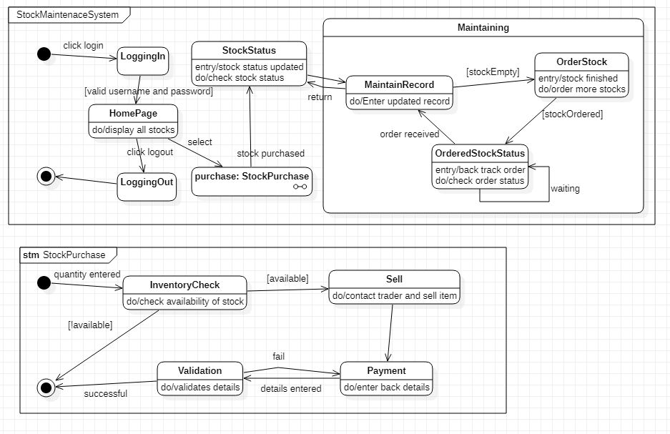

The state diagram above gives us the states involved in purchasing a product and placing the order for the

same. There is first an inventory check ,where is stock of products is noted and if the stock is less than

minimum an order is placed by first searching for suitable trader . if a suitable trader is found , the order is

placed and verified by the accountant. After the accountant has verified a payment is made for the

products purchased.

D) **Advanced use case diagram:-**

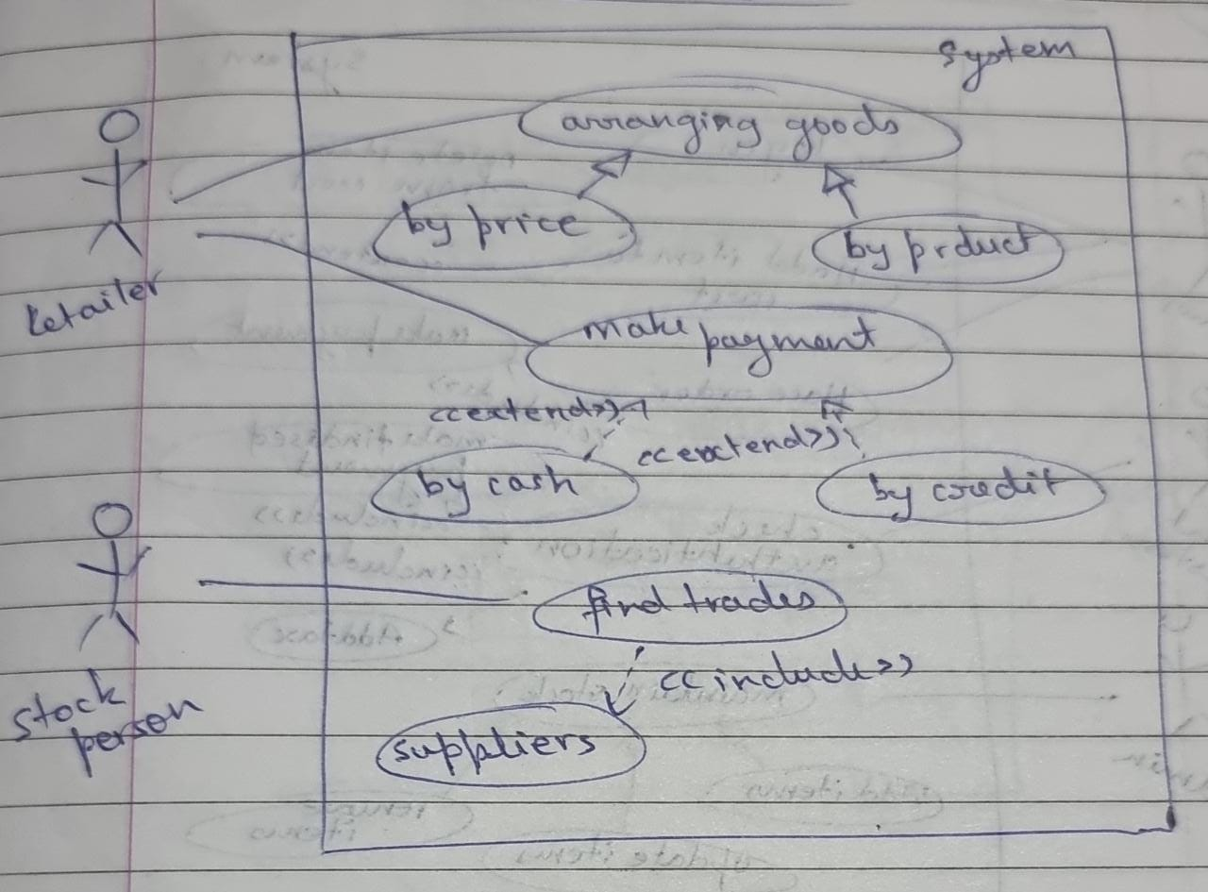



**Actors:**

Retailer: a person who sells the products

Stock person : a person who keeps check of the stock

**Use Cases:**

Purchase item: allows a user to purchase any product

Make payment: accepts the payment

Supply stock: keeps track of the stock supplied

Find traders: provides a list of traders

E) **Advanced sequence diagram :-**

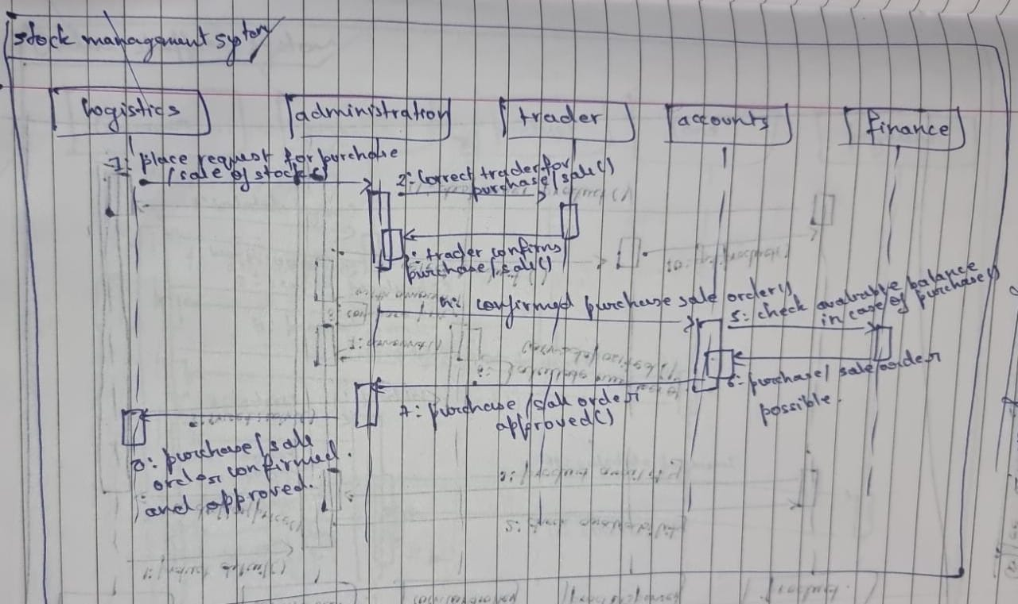



The above sequence diagram give the steps involved in placing request for purchase/sale of stock Contact

seller for purchase/sale,Seller confirms purchase/sale Confirmed purchase/sale order, Check available

balance in case of purchase order Purchase/sale order possible, Purchase/sale order approved, Purchase/

sale of stock confirmed and approved.

F) **Adanvced activity diagram:-**

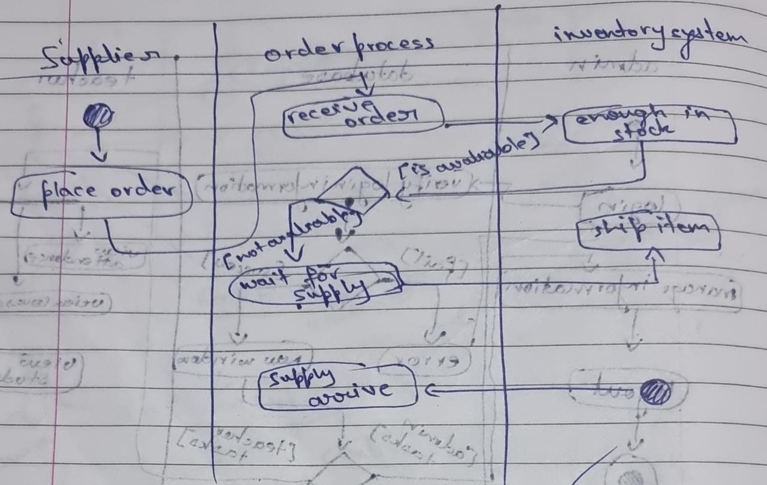

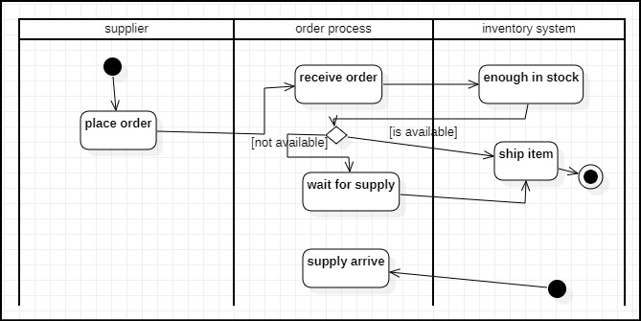

The state diagram above gives us the states involved in purchasing a product and placing the order for the

same. There is first an inventory check ,where is stock of products is noted and if the stock is less than

minimum an order is placed by first searching for suitable trader .

**4. COFFEE VENDING MACHINE :-**

A) **SRS**

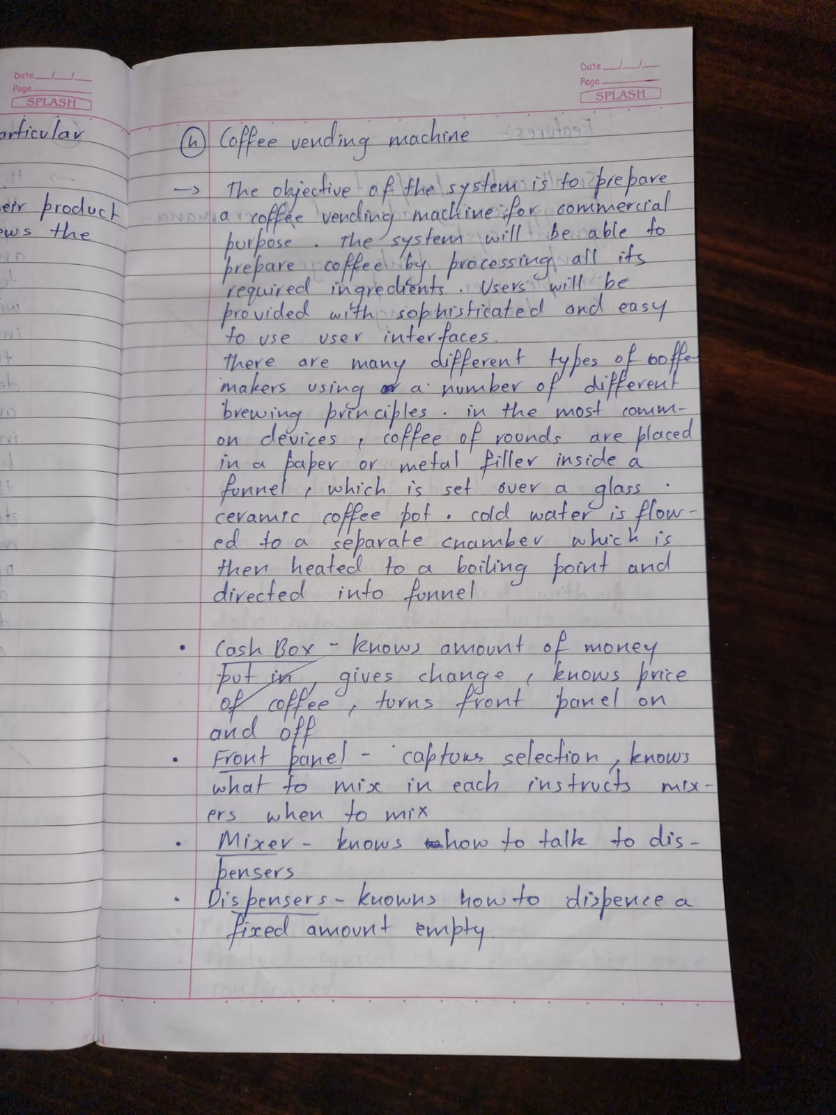

A) **Advanced class diagram :-**

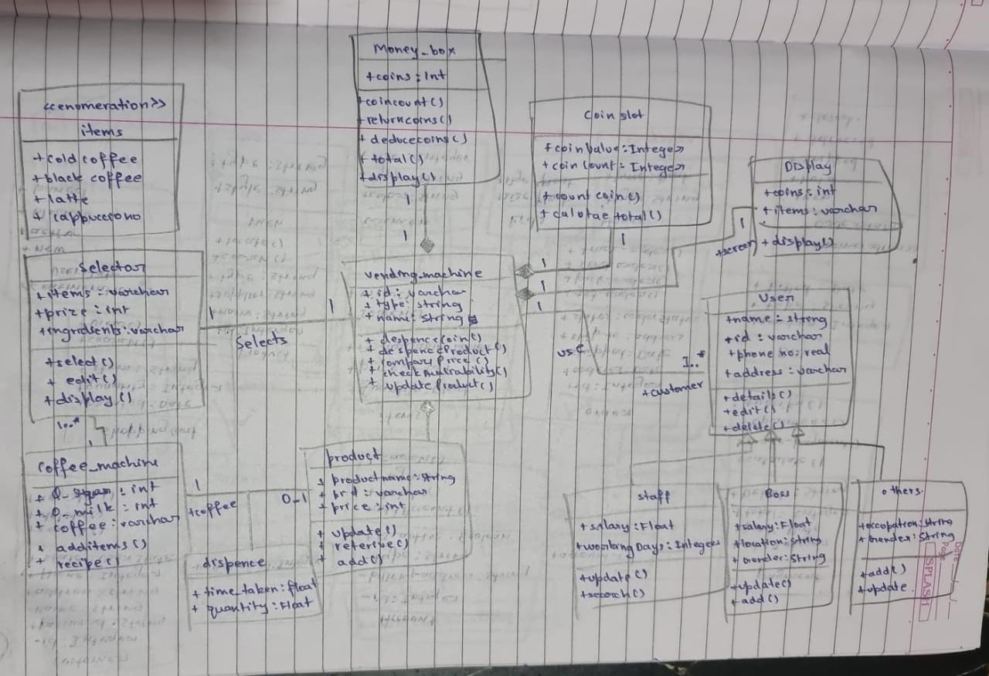



The vending machine must have money box, coin slot, display screen and products i.e coffee for the machine to be

used.The user on selecting a coffee ,the coffee machine must be able to dispense the selected coffee to the user. The

user shall get empty cup placed right below the filter.The user shall be able to choose his preferred beverage from

the list of options.There are different types of coffee such as cappuccino, black coffee, cold coffee and latte. Each

type of coffee has a price and a name. A customer can buy their choice of coffee by selecting the button of their

coffee and paying for the same through the coin box.

C) **Advanced state diagram:-**

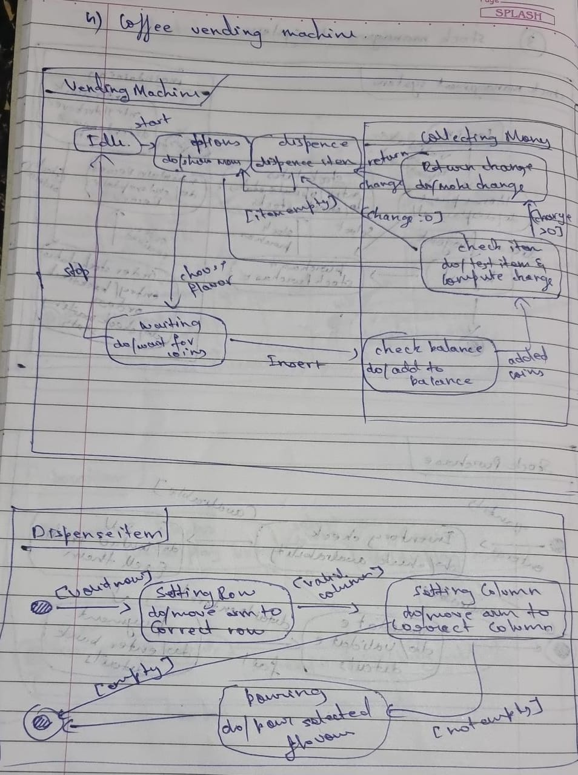



Initially the vending machine is in the waiting state. The machine displays the selected item selected by the user.

When the person inserts a coin the machine adds the amount to he cumulative balance. After adding some coins, a

person can select nay item. If item is empty or balance is insufficient, the machine waits for another selection.

Otherwise the machine dispense the item and returns the appropriate change.The state diagram for coffee vending

machine has a submachine called dispense Item ,which has the states for dispensing an item from the vending

machine.the arm of the machine first moves to an appropriate row, when ready, moves to an appropriate column and

when the arm is ready it finally dispences the item from the machine.

D) **Advanced use case diagram : -**

**Actors:**

Customer :a person who uses the coffee vending machine

**Use Case:**

Display payment details : displays the payment details

Request coffee : allows user to order their coffee

Make payment : accepts money for the coffee

Load ingredients : is the use case where the operator fills the machine with ingredients

Dispense coffee : the coffee ordered is prepared and give

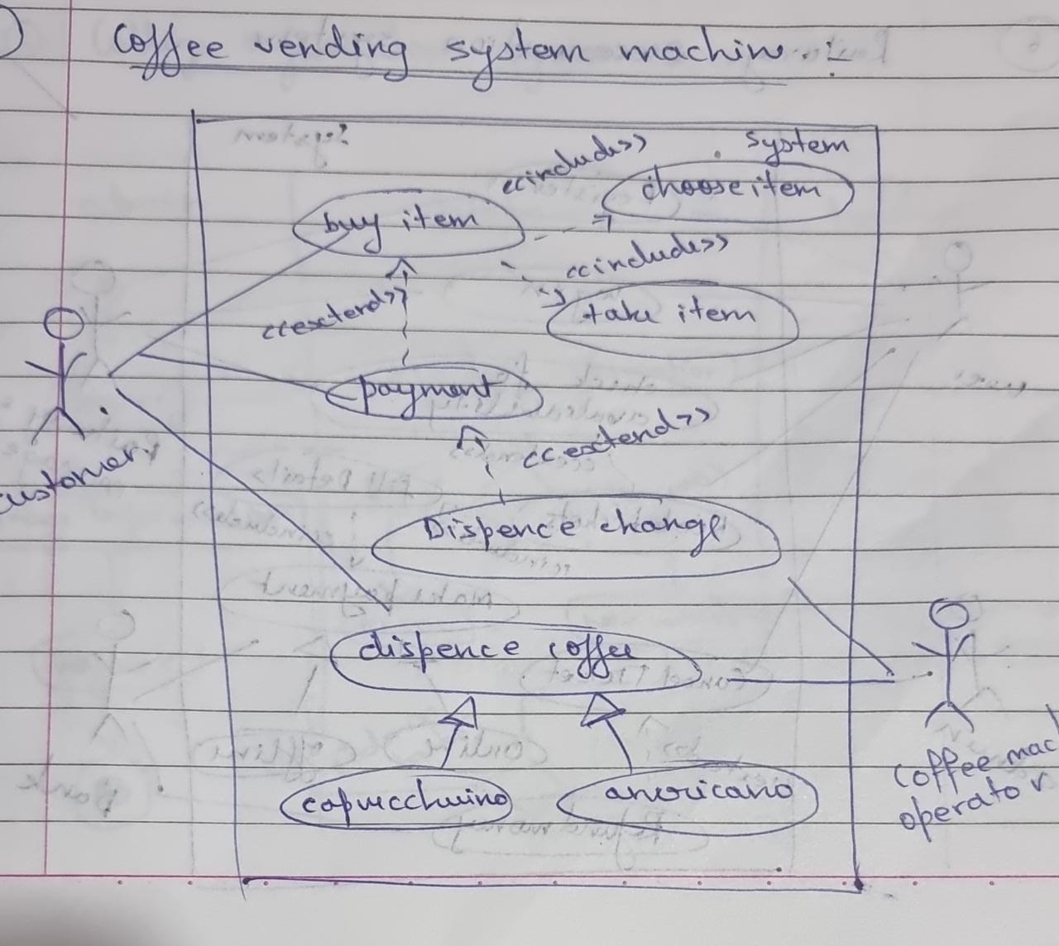



E) **Advanced sequence diagram ;-**

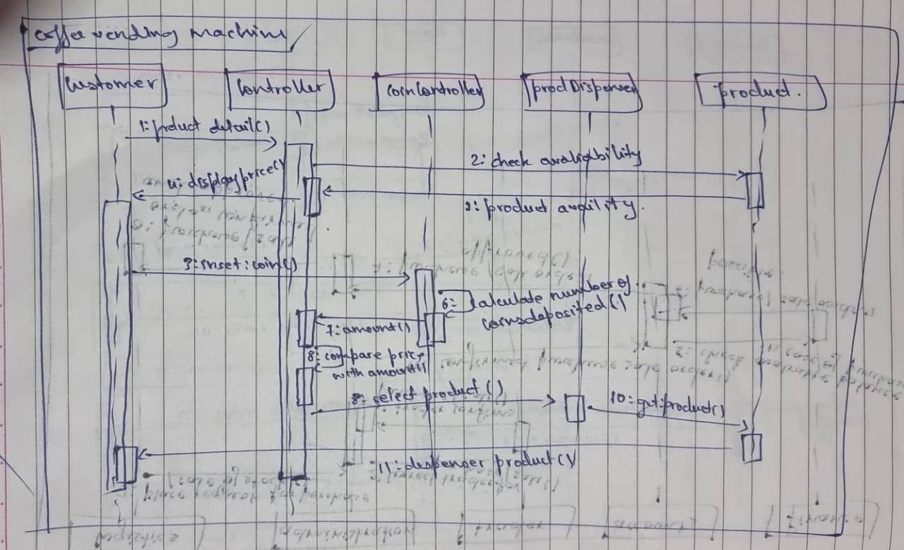



The above sequence diagram gives us the steps involved in dispensing a product from the coffee machine.

First an enquiry for the product is made and if available the coins are inserted and calculated ,if correct

the product is dispensed .

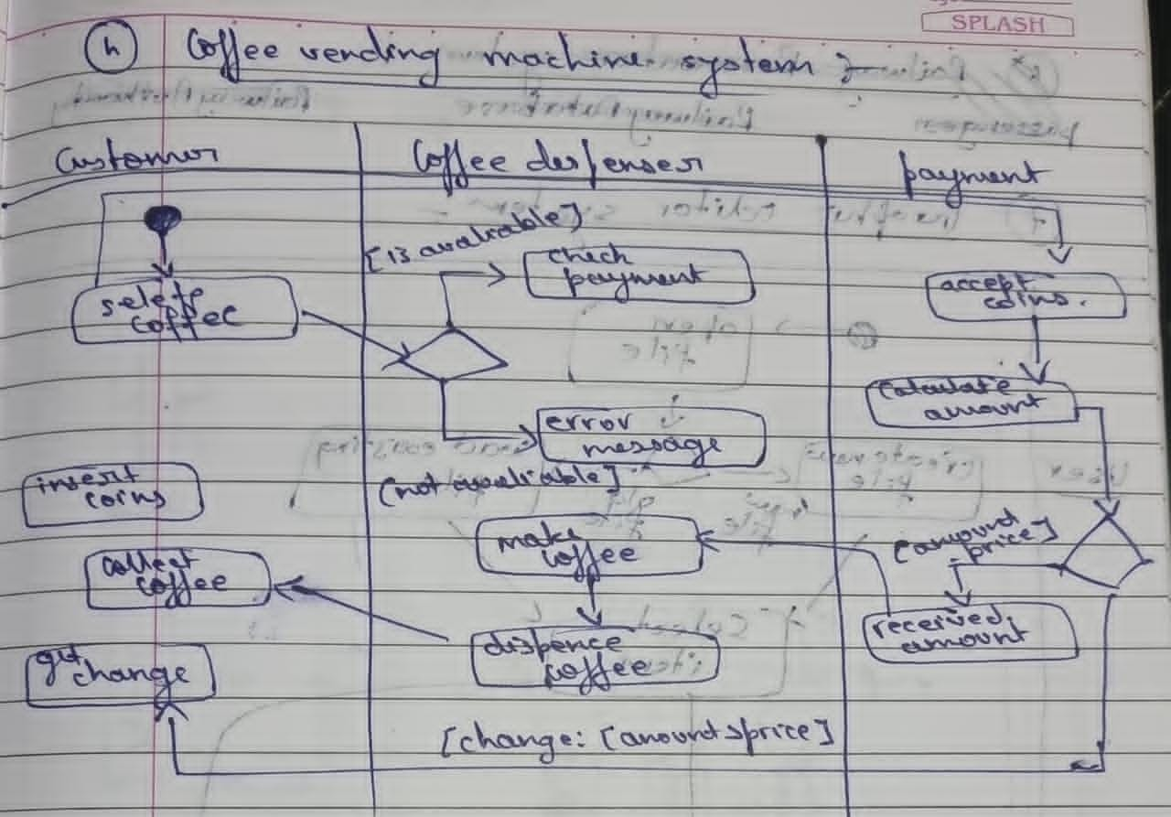



The advanced activity diagram has three swim lanes i.e customer, coffee dispenser and payment. The

customer can select coffee ,insert coins, get change and collect coffee. The coffee dispenser checks for

payment and makes ,dispenses the coffee. The payment lane accepts coins, calculates amount and gives

back the change.

5. **ONLINE SHOPPING SYSTEM :-**

A) **SRS**

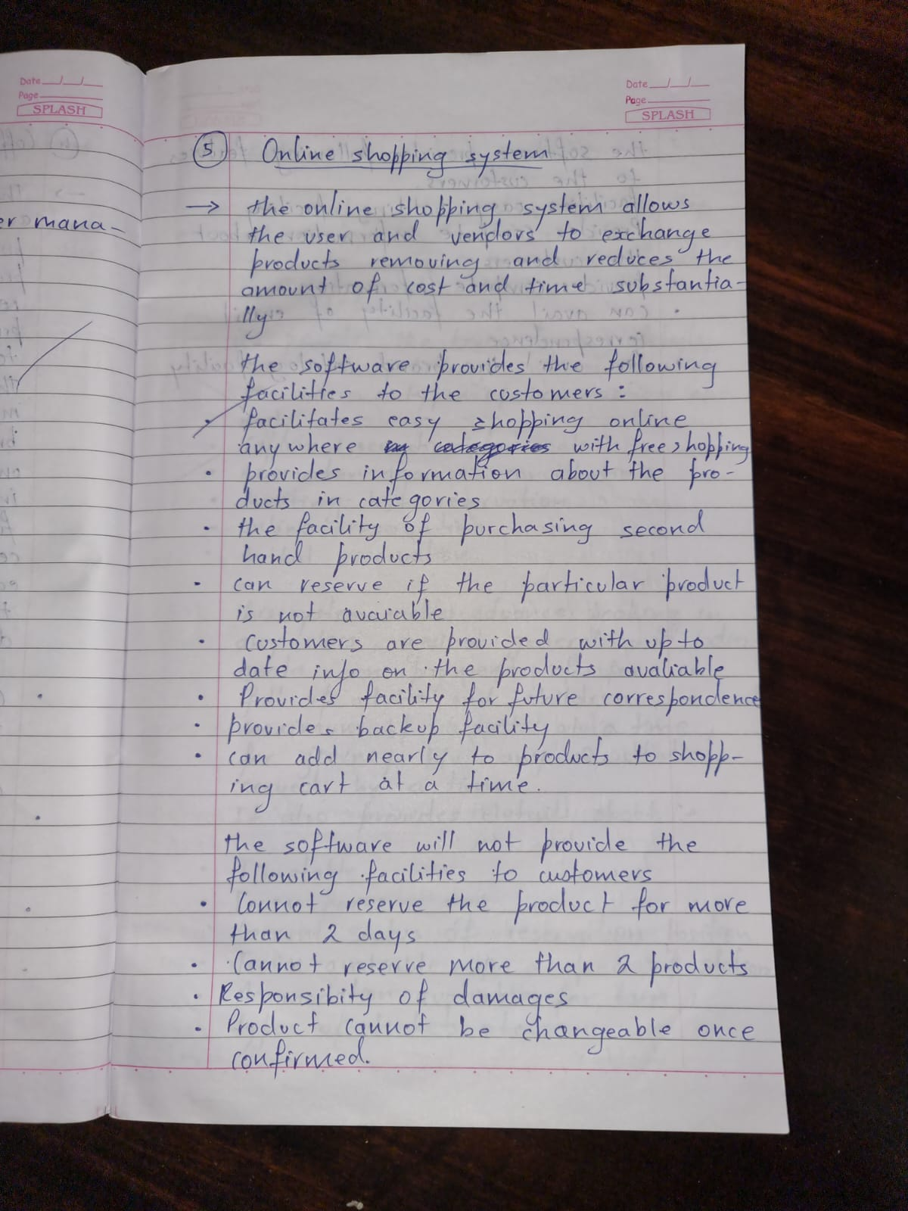

B) **Advanced class diagram :-**

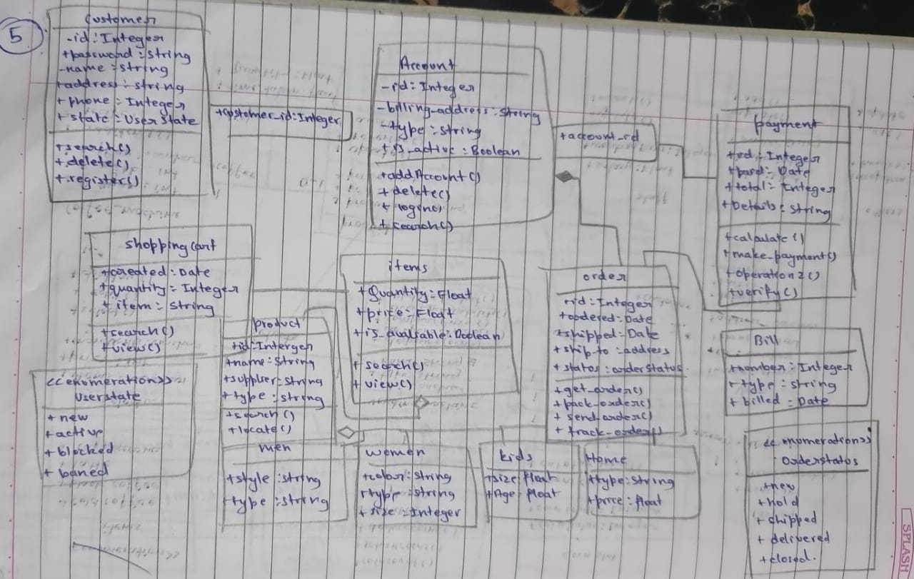



The online shopping system has customers who must have an account in the online website where he/she can

purchase products.If customer wants to buy the product then he/she must be registered, unregistered user can’t go to

the shopping cart.Customer login to the system by entering valid user id and password for the shopping.The

products sold for customers are sold for various categories like men, women, kids and home products.After the

payment or surf the product the customer will logged out.

C) **Advnaced state diagram :-**

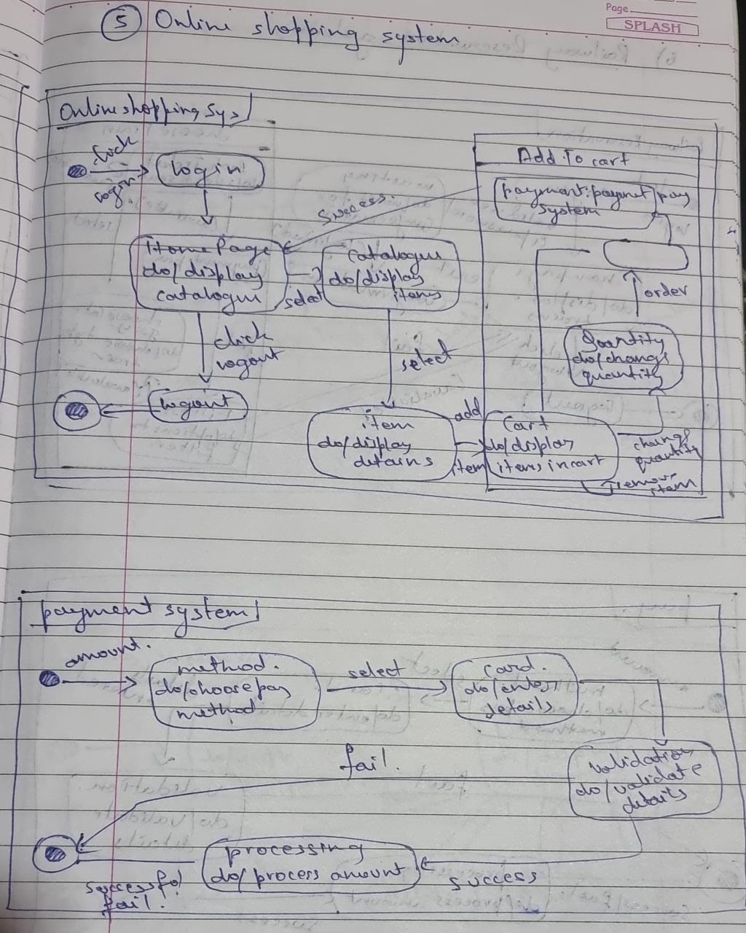



The simple state chart diagram gives us states in purchasing a order and paying for the order. The

customer is first mad to register and then login into their account. Then the items are displayed, where

they can select their choice and add them to cart or reserve or order them. The transaction details are

displayed.The advanced state chart diagram has states explaining the product purchase and payment. It

has two sub machines i.e product selection and checkout product. Product selection allows us to select

products and add them to cart. Checkout product has states explaining the payment methods and

validating the methods.

D) **Advanced use case diagram :-**

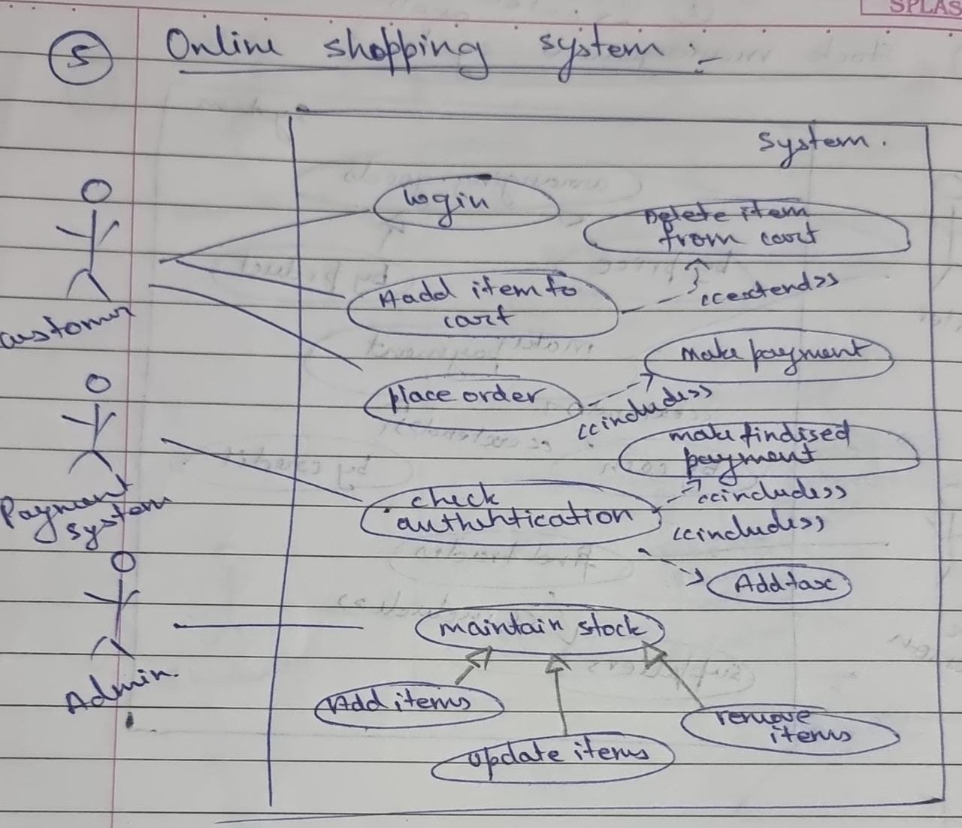



**Actors:**

Customer: a person who uses the online shopping system

Payment System: person who handles the payment

Admin : a person who manages the delivery

**Use Case:**

view product details : displays all product details

Place order : order the items present in the cart

Make payment : accepts payment for the products purchased

Deliver product : delivery of the product is handled

Supply Product : product supply is maintained

Maintain Stock : stock availability is checked

E) **Advnaced sequence diagram :-**

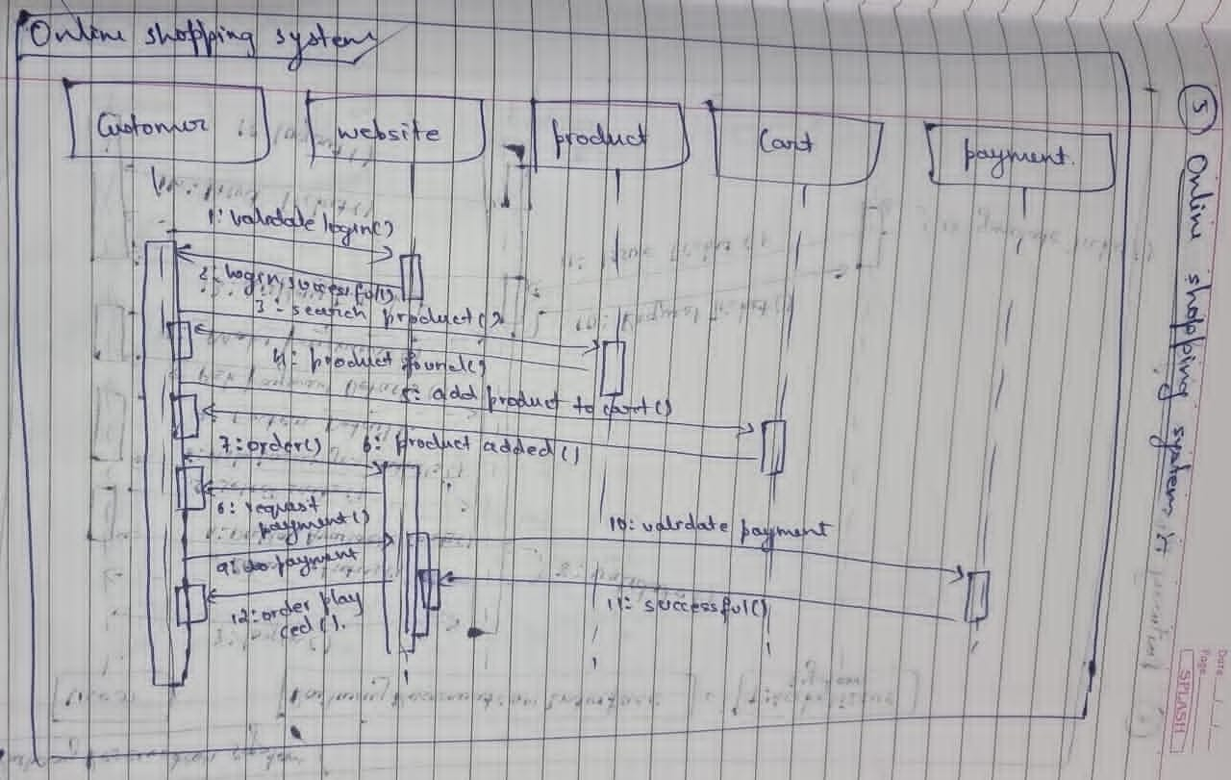



The customer adds items into cart and reply from interface is sent, the customer places the order, the

online interface requests for payment, the customer provides details and confirmation is sent, the

customer logs out, the logout confirmation is sent to the customer

F) **Advnaced activity diagram :-**

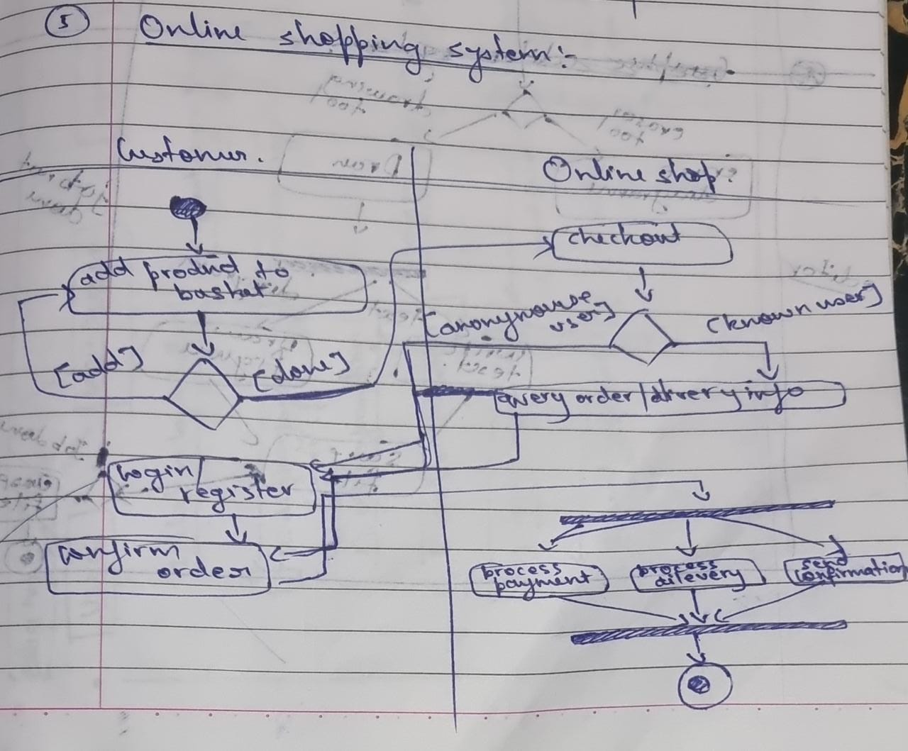



**6. RAILWAY RESERVATION SYSTEM :-**

A) **SRS:-**

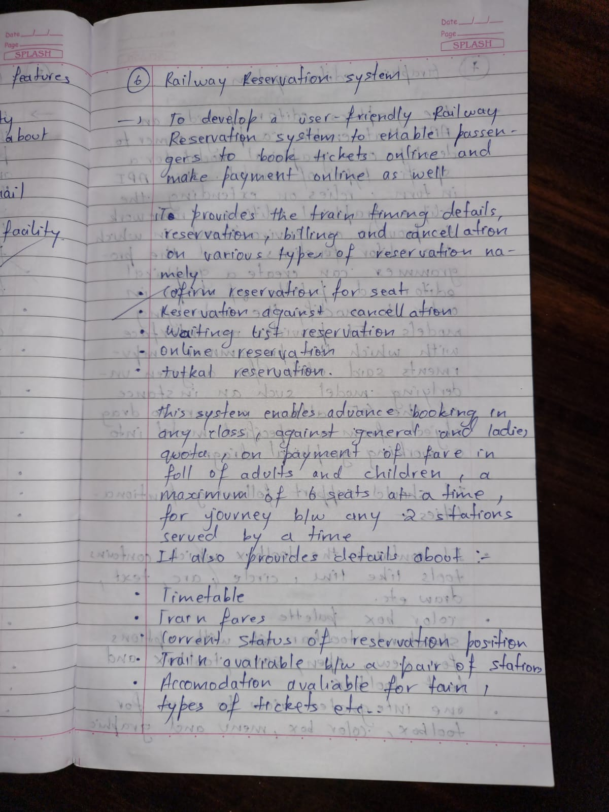

B) **Advanced class diagram :-**

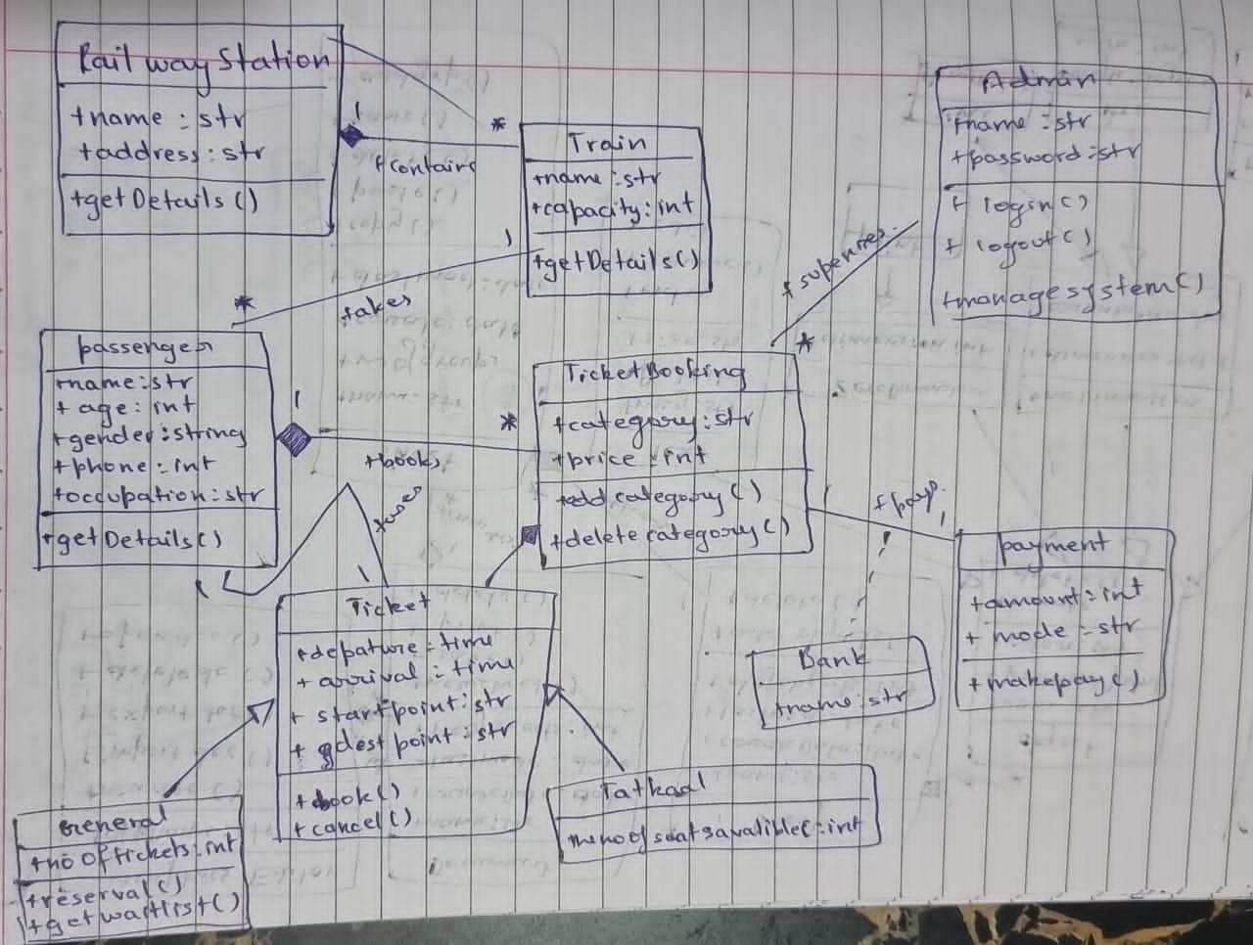



The admin manages the trains and reservation related to railway reservation system. There are three types of

reservation, I.e RAC, waiting and confirmed.The passengers with a reservation goes to one or the other

reservation.A train consists of coaches and engine.A passenger pays for the ticket booked .Tickets can be booked in

two ways by i-ticket or by e-ticket booking.

C) **Advances state disgram :-**

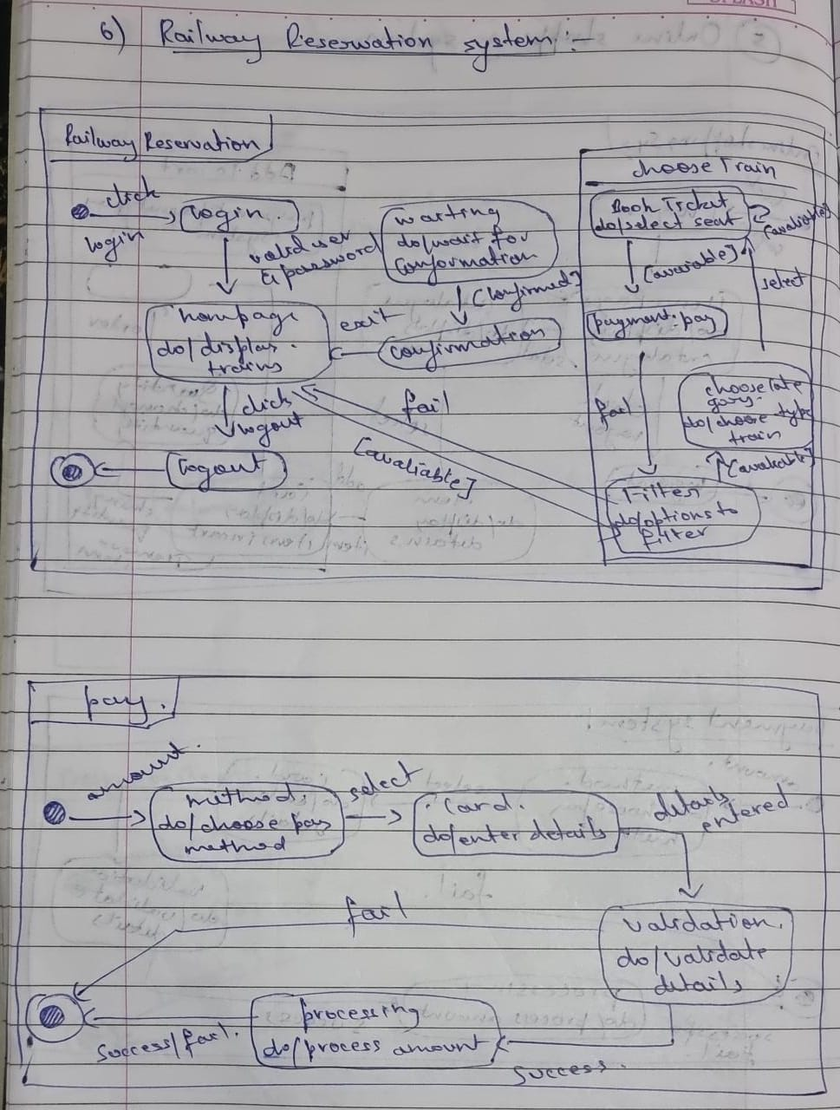

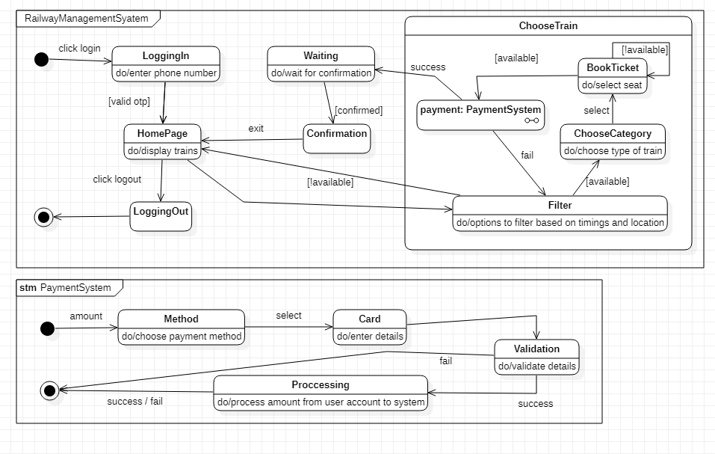

The simple state diagram gives the states involved in booking a train ticket and paying for the same. The

user can see the train details and book a train for a particular source and destination . on timeout an error

message is displayed and redirected to the main page. The user can then select a train and make payment

for itThe advanced state diagram has states for paying the ticket.from the ready state the user goes to

payment initiation after which the card details are accepted and an OTP is sent to the registered mobile

number. On verification the money is deducted and ticket is sent to the customer.

D) **Advanced use case diagram :-**

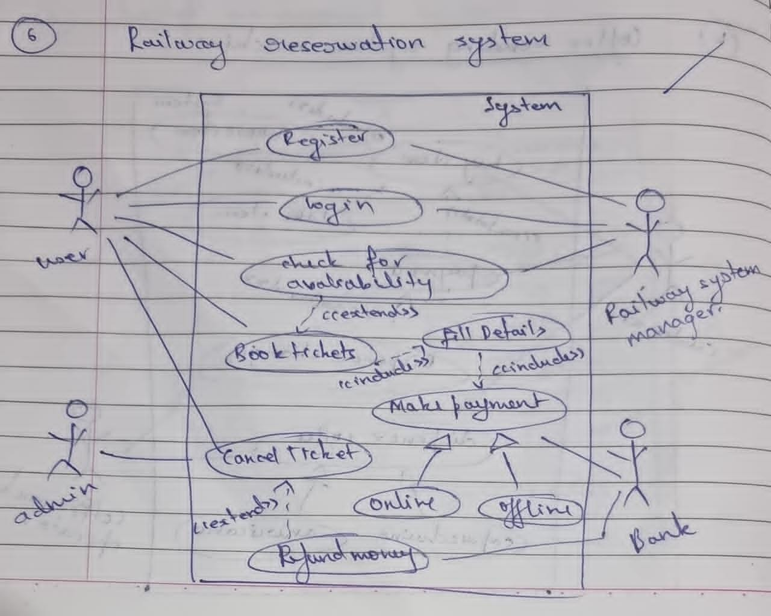



**Actors:**

User: uses the railway reservation system.

Admin: manages all information

Railway System: System that is used for train ticket reservation.

**Use Case:**

Register: The first time user has to create a account in railway system.

Book Ticket: User can select the type of coach and no of seats and book the ticket.

Make payment: System displays the payment details. User can make his payment.

E) **Advanced sequence diagram :-**

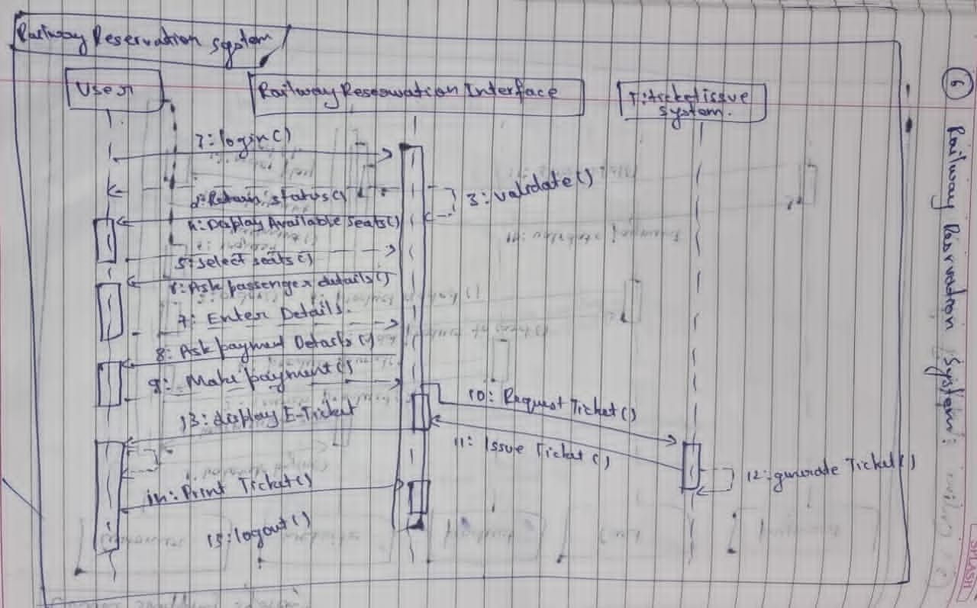



User logs into the railway reservation system.Admin verifies the login details.System establishes

secure communication.User checks for availability of trains .Admin updates the train details. System

displays the train details. User books tickets.System displays payment details. User makes the

payment.System issues the e-ticket. User logs out .

F) **Advanced activity diagram :-**

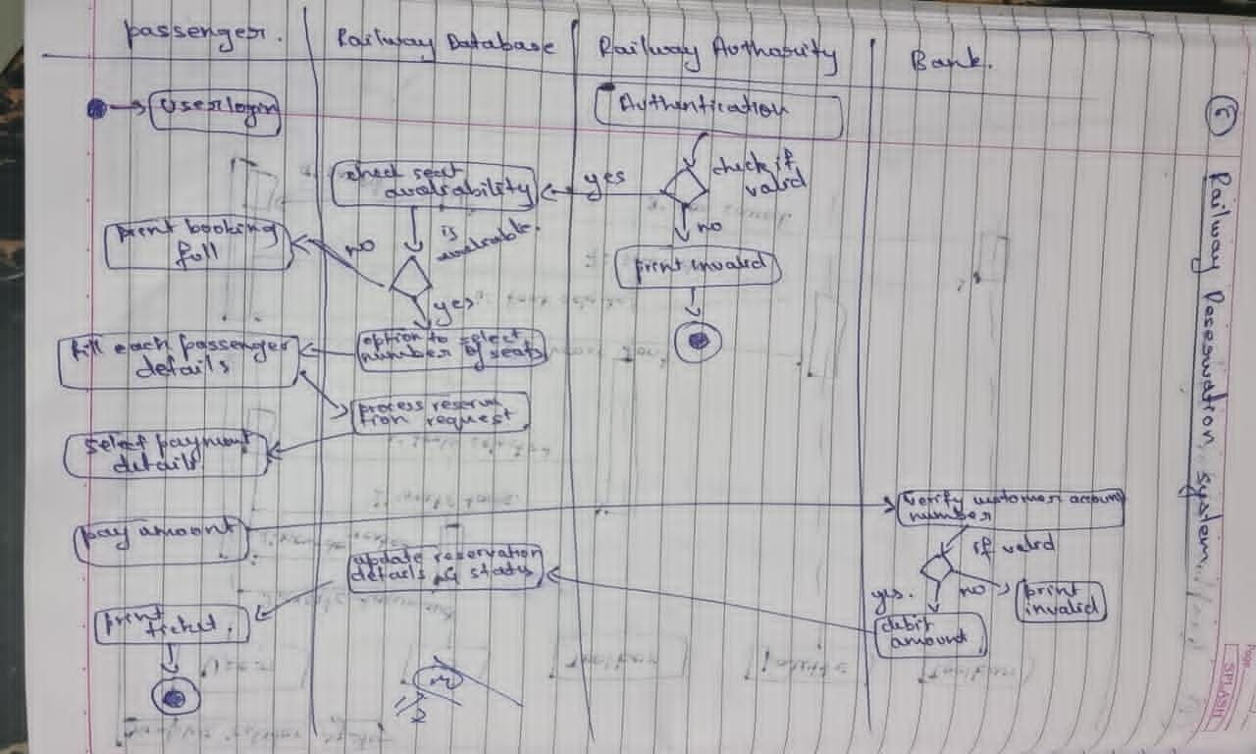



The activity diagram tells about the steps happening while canceling a ticket which is booked.the user

first need to login and select his ticket, confirm cancellation, request refund and print the canceled ticket

and logout.

**7. GRAPHICS EDITOR SYSTEM :-**

A) **SRS :-**

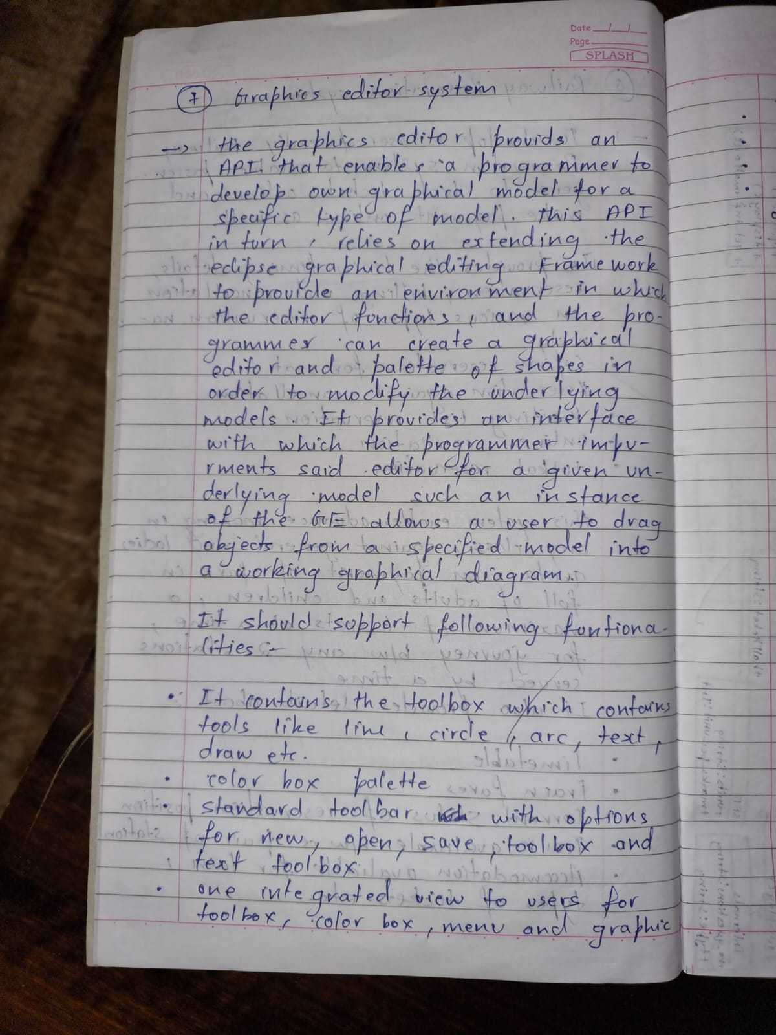

A) **Advanced class diagram :-**

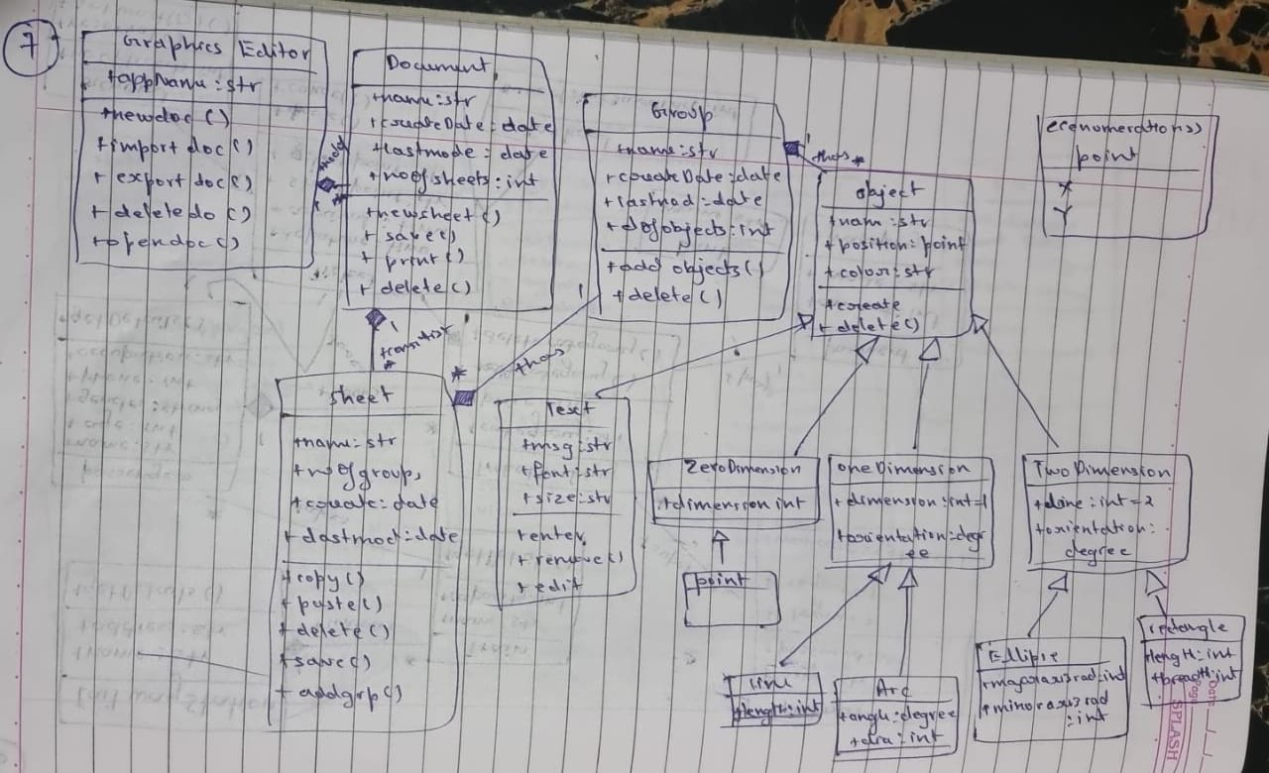



The graphical editor has documents consisting of several sheets. Each sheet contains drawing objects, including text,

geometrical objects and groups. A group is simply a set of drawing objects. A geometrical object includes circle,

ellipse, rectangles, lines and squares.

B) **Advanced state diagram :-**

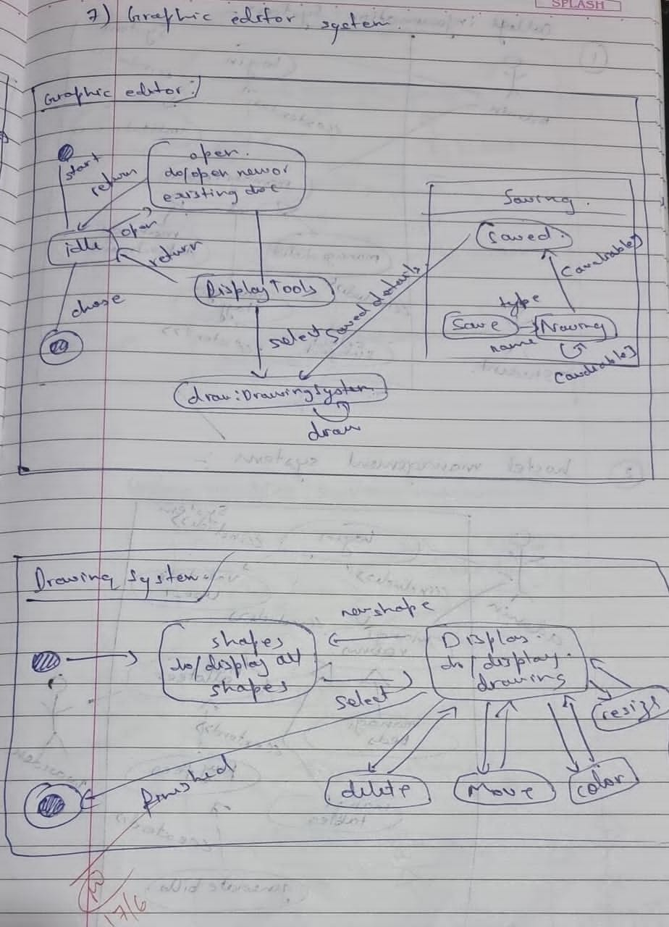

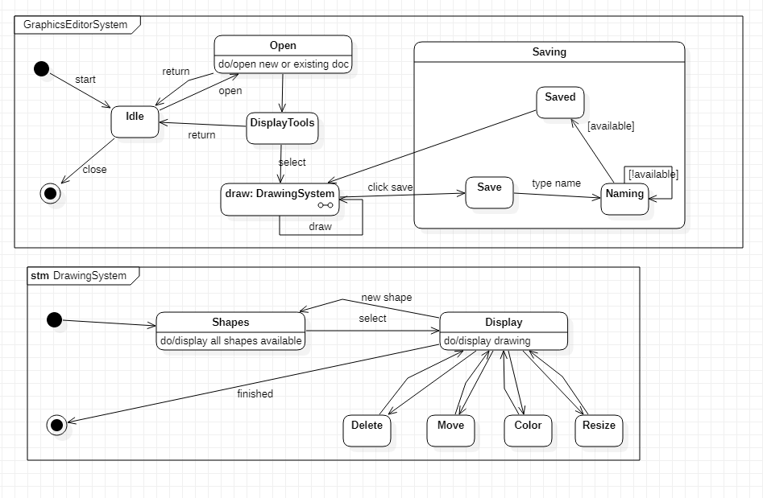

The simple state diagram and advanced state diagram gives the states involved in making and saving a

graphic file.first the user selects a new document and draws graphics. If there is a mistake he can erase

and select a color from the color palet. He can then save the file created.The advanced state diagram had a

composite state called saving where the user can save the file in their desired location.

D) **Advnaced use case diagram :-**

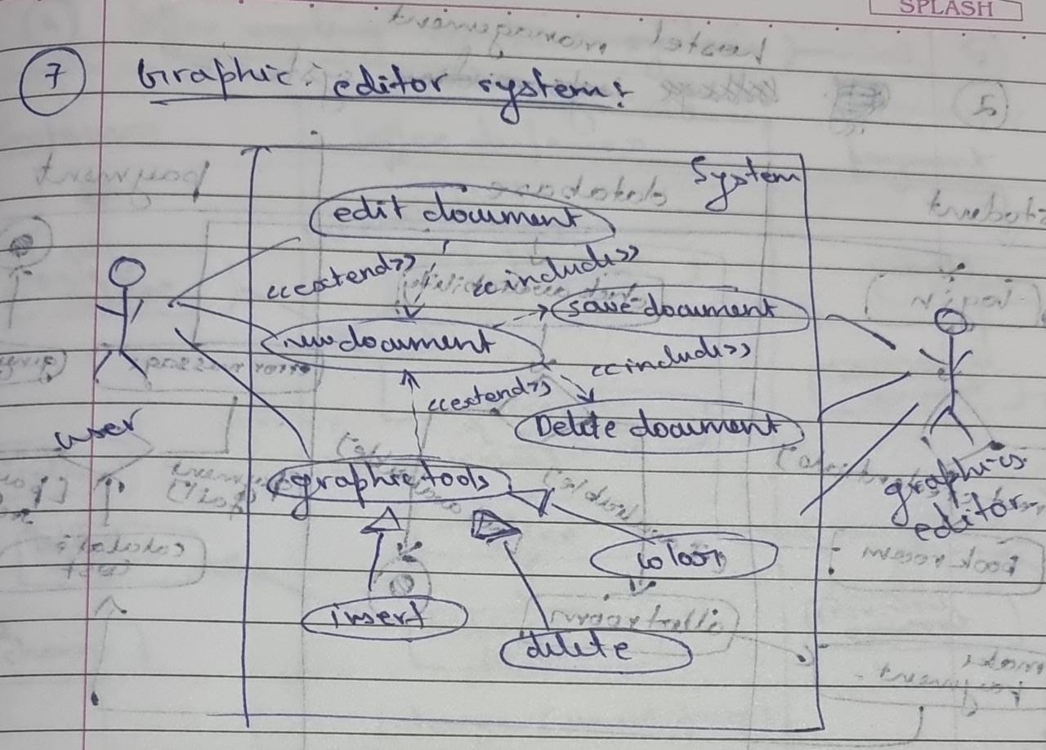



**Actors :**

User: the person who uses the graphic system

Graphics system: manages the system

**Use case:**

Create document : performs creation of new document

Edit document: performs editing of document

Display toolbox: displays the available tools

Add graphic object : insert a new graphic object

Choose tools from toolbox : allows user to choose tools

Delete document : Permanently deletes the document

E) **Advnaced sequence daigram :-**

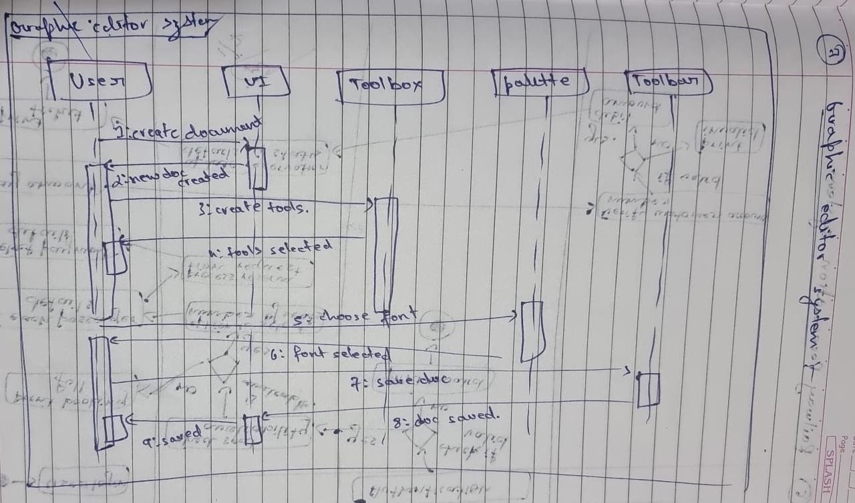



The graphics editor displays options to user, the user selects an option, the graphics editor displays shapes

,the user selects a shape, parameters are asked by the editor, user enters all the required parameter, the

graphics editor displays the diagram

D) Advanced activity daigram :-

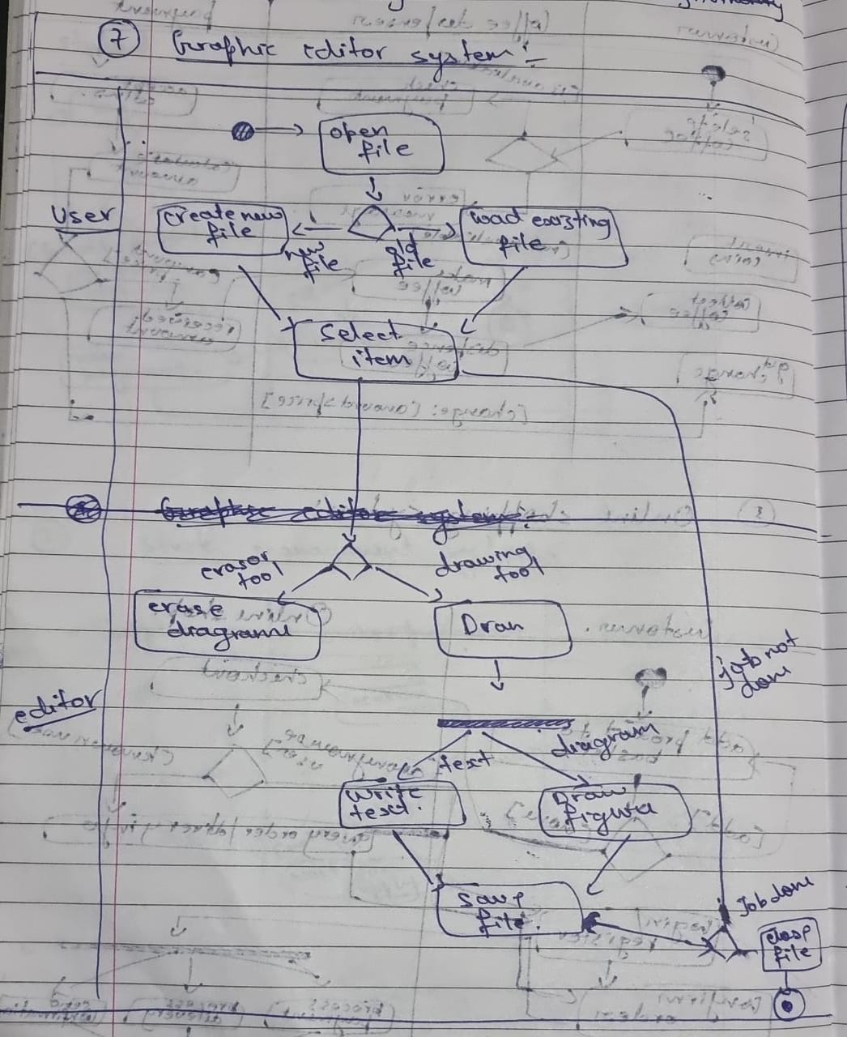



The advanced activity diagram gives the states involved in making and saving a graphic file. The user

selects a new document and draws graphics, saves the file and closes it.